Big Data

# Temas

1. **Big Data** General Understanding
2. **Hadoop**:  General Architecture, Hadoop v1 vs v2, Problems in Hadoop v1, Improvements in Hadoop v2, Understanding the relation between HW and SW,
3. **MapReduce**: in General MapReduce Architecture / Phases, Explanation of the execution of MapReduce jobs, InputFormat, Partitioner, Shuffle and Sort, Parallelism in MapReduce
4. Apache **Sqoop**: Definition, Use cases, import/export
5. Apache **Pig**: Definition, Use cases, UDFs, Parallelism in Pig, Pros and Cons
6. **Hive**:  Use Case, differencias con RDBMS, Architecture, Partitioning, tablas Externa vs Interna, Serializer / Deserializer, Data Model / Advance Functions
7. **Spark**: Preguntas básica, RDD, Dataframes, arquitectura, jobs

Contents

Temas 1

Big Data 4

Que es big data 4

V’s 4

Roles en big data 5

Pipeline 6

Tools 7

Datos 7

Precedencia de los datos 7

Bases de Datos 8

Teorema CAP 8

Modelos de Consistencia 9

Categorías 11

Hadoop 14

Hadoop Common 15

Hadoop Distributed File System 17

MapReduce 18

Hadoop versions 19

Run Job process 30

HDFS read data flow 31

HDFS write data flow 31

MapReduce 32

MapReduce Job 32

Sqoop 33

Pig 43

Hive 47

Spark 61

Features of Apache Spark 61

Spark Built on Hadoop 62

Components of Spark 62

Resilient Distributed Datasets 63

Data Sharing is Slow in MapReduce 64

Iterative Operations on MapReduce 64

Data Sharing using Spark RDD 65

Iterative Operations on Spark RDD 65

Apache open source Hadoop ecosystem elements 67

Other Apache Hadoop-related open source projects 69

# Big Data

## Que es big data

Big Data: Set de herramientas, tecnologías y procesos utilizados para explotar datasets.

Proceso de recolección de grandes cantidades de datos y su inmediato análisis para encontrar información oculta, patrones recurrentes, nuevas correlaciones, etc.; el conjunto de datos es tan grande y complejo que los medios tradicionales de procesamiento son ineficaces. Y es que estamos hablando de desafíos como analizar, capturar, recolectar, buscar, compartir, almacenar, transferir, visualizar, etc., ingentes cantidades de información, obtener conocimiento en tiempo real y poner todos los sentidos en la protección de datos personales.

•  Alta escalabilidad • Procesamiento paralelo • Baja latencia • Datos no estructurados y estructurados • NoSQL

Top use case families that have emerged around Hadoop are: Data Discovery, Single View, Predictive Analytics, Active Archive, ETL Onboard, Data Enrichment, etc.

Hadoop is an OLAP data platform and it evolved as part of the database industry. Hadoop is:  
- a scalable, fault tolerant, open source framework for the distributed storing (HDFS) and processing (YARN) of large sets of data on commodity hardware  
- a clean-room implementation of two papers from Google  
- optimized for schema-on-read use cases  
- the basis of the enterprise "data lake" architecture

Hadoop is an open source project governed by the Apache Software Foundation (ASF)

Apache Bigtop is to Hadoop what Debian is to Linux

ODPi helps ASF with harmonizing industry expectations around the Hadoop ecosystem.

## V’s

The 3Vs of Big Data (Volume, Velocity and Variety) are driving the adoption of Apache Hadoop:  
- Industry expects 44ZB of data by 2020  
- Existing data architectures make data inaccessible, incomplete, irrelevant, and expensive

**Volumen**: grandes volúmenes de información.  Se está pasando de hablar en Gigabytes o Terabytes a tamaños de datos de Petabytes, Exabytes o Zettabytes.

**Variedad**: información de tipos muy diversos.

**Velocidad**: velocidad con la que se genera la información

**Variabilidad**: Diversidad entre datos del mismo tipo

Valor

## Roles en big data

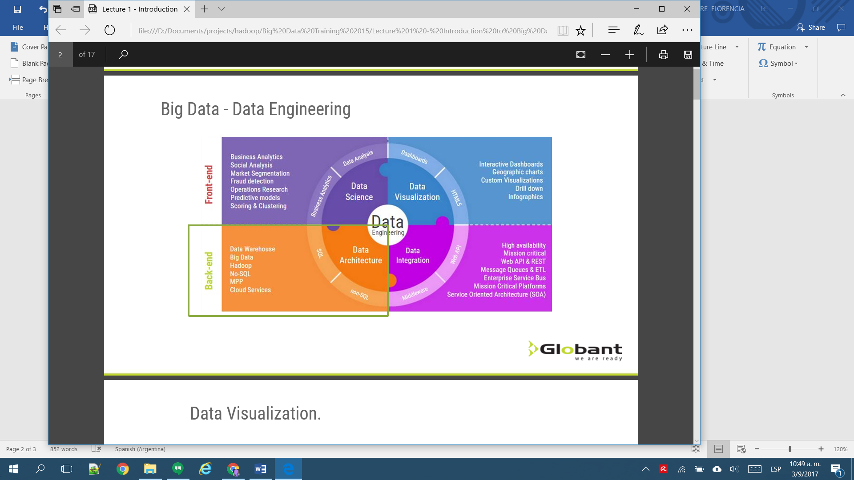

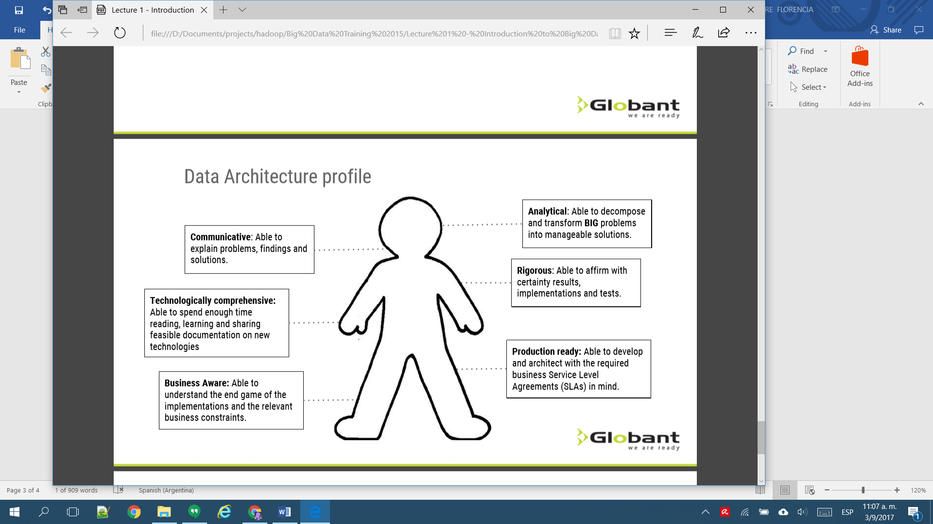

Data Architect Profile

**Preguntas**

What does the customer want to do with his data?

Where is the Data now?

How much data is it?

How fast does it growth?

How fast do we need to process the results?

What technology does the customer already have?

What sort of end user will consume the results and how?

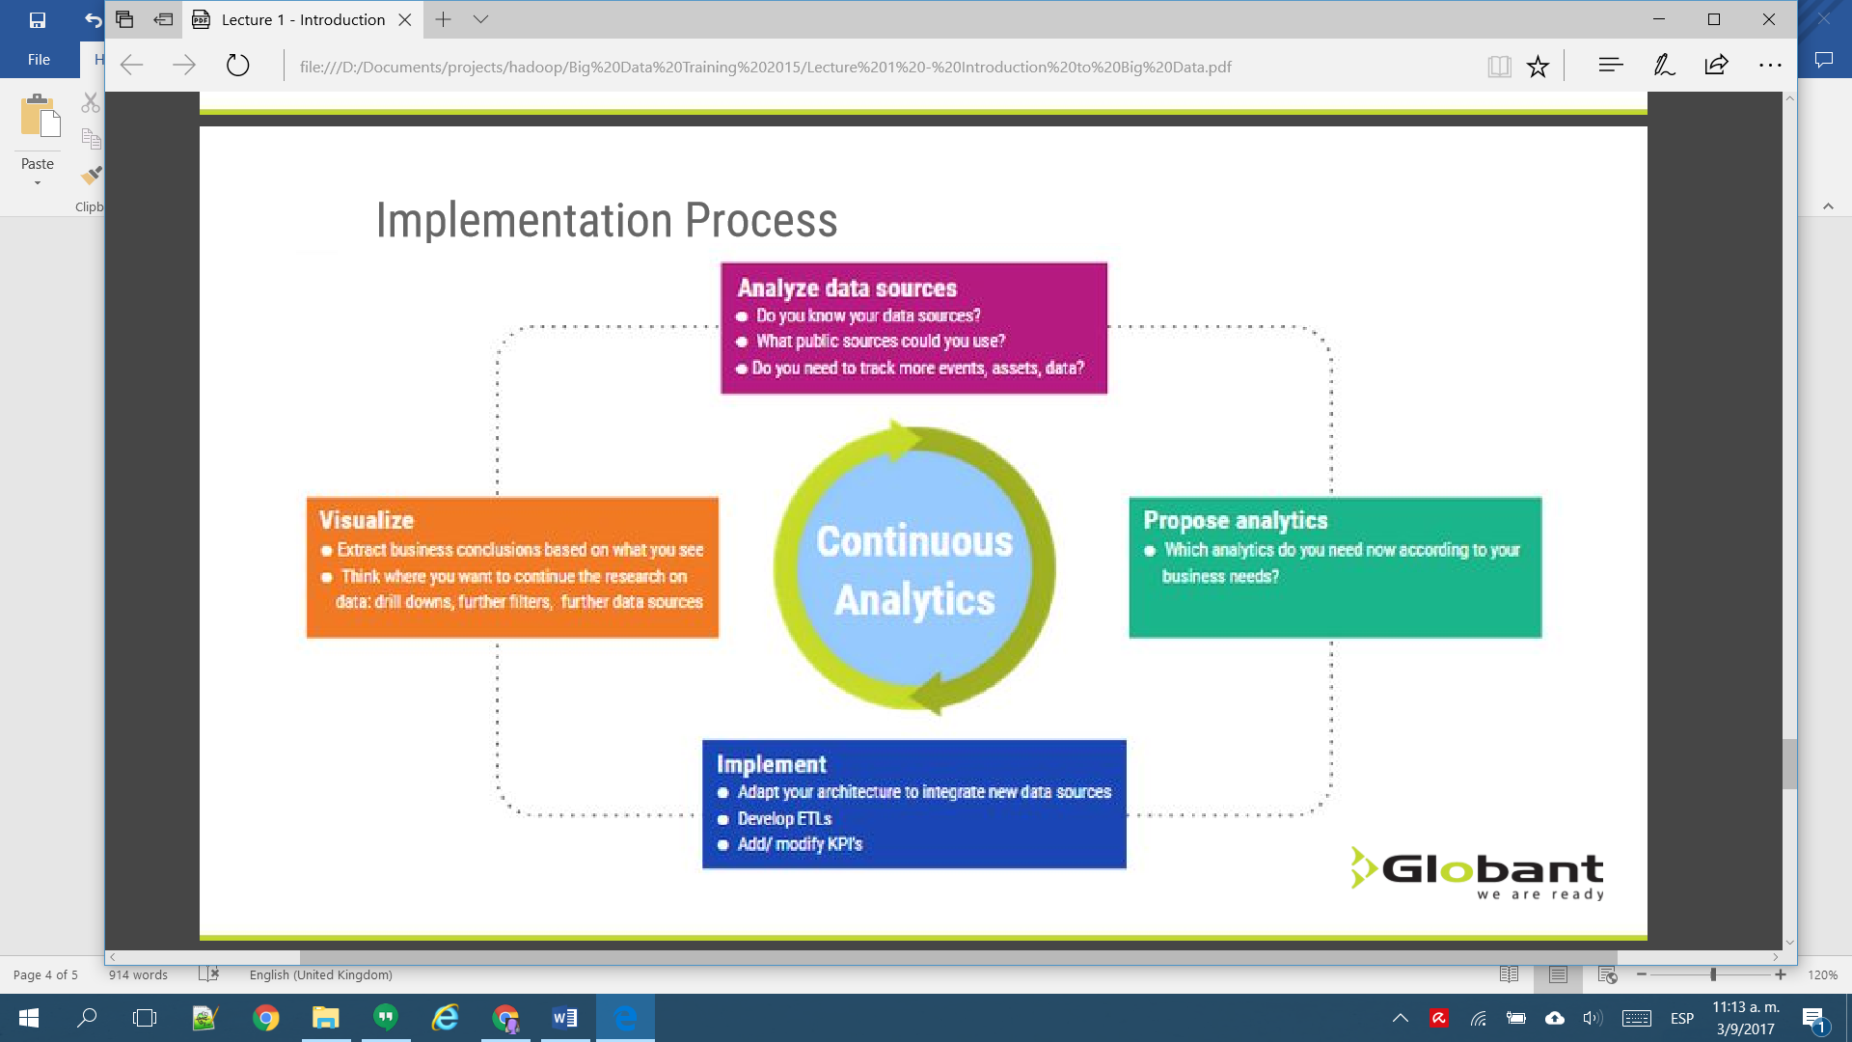

## Pipeline

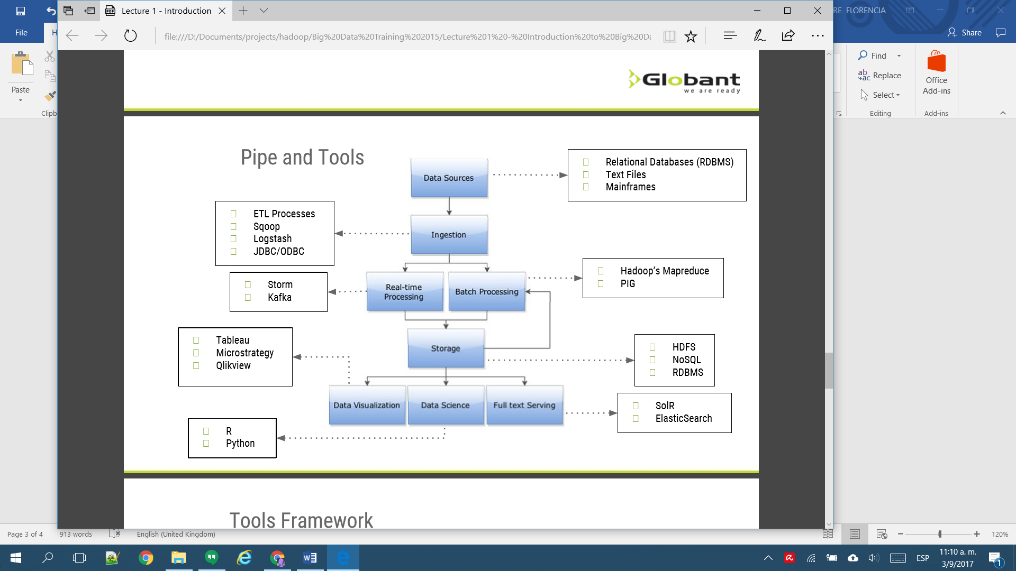

## Tools

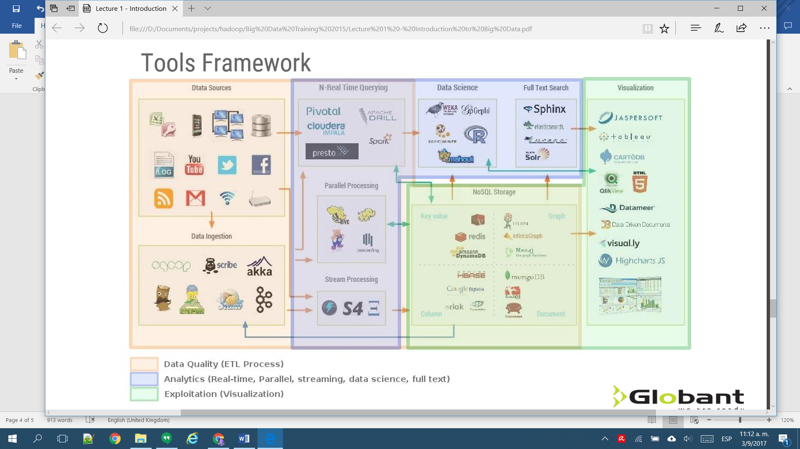

## Datos

* **Datos estructurados:** datos que tienen bien definidos su longitud y su formato, como las fechas, los números o las cadenas de caracteres. Se almacenan en tablas. Un ejemplo son las bases de datos relacionales y las hojas de cálculo.
* **Datos no estructurados:** datos en el formato tal y como fueron recolectados, carecen de un formato específico. No se pueden almacenar dentro de una tabla ya que no se puede desgranar su información a tipos básicos de datos. Algunos ejemplos son los PDF, documentos multimedia, correos electrónicos o documentos de texto.
* **Datos semiestructurados:** datos que no se limitan a campos determinados, pero que contiene marcadores para separar los diferentes elementos. Es una información poco regular como para ser gestionada de una forma estándar. Estos datos poseen sus propios metadatos semiestructurados​ que describen los objetos y las relaciones entre ellos, y pueden acabar siendo aceptados por convención. Un ejemplo es el HTML, el XML o el JSON.

### Precedencia de los datos

**Generados por las personas**: el hecho de enviar correos electrónicos o mensajes por WhatsApp, publicar un estado en Facebook, tuitear contenidos o responder a una encuesta por la calle son cosas que hacemos a diario y que crean nuevos datos y metadatos que pueden ser analizados. Se estima que cada minuto al día se envían más de 200 millones de correos electrónicos, se comparten más de 700.000 piezas de contenido en Facebook, se realizan dos millones de búsquedas en Google o se editan 48 horas de vídeo en YouTube. Por otro lado, las trazas de utilización en un sistema ERP, incluir registros en una base de datos o introducir información en una hoja de cálculo son otras formas de generar estos datos.

**Transacciones de datos**: la facturación, las llamadas o las transacciones entre cuentas generan información que tratada puede ser datos relevantes. Un ejemplo más claro lo encontraremos en las transacciones bancarias: lo que el usuario conoce como un ingreso de X euros, la computación lo interpretará como una acción llevada a cabo en una fecha y momento determinado, en un lugar concreto, entre unos usuarios registrados, y más metadatos.

**Marketing electrónico y web**: se generan una gran cantidad de datos cuando se navega por internet. Con la web 2.0 se ha roto el paradigma webmaster-contenido-lector y los mismos usuarios se convierten en creadores de contenido gracias a su interacción con el sitio. Existen muchas herramientas de seguimiento utilizadas en su mayoría con fines de marketing y análisis de negocio. Los movimientos de ratón quedan grabados en mapas de calor y queda registro de cuánto pasamos en cada página y cuándo las visitamos.

**Máquina a máquina** (machine to machine, M2M): son las tecnologías que comparten datos con dispositivos: medidores, sensores de temperatura, de luz, de altura, de presión, de sonido… que transforman las magnitudes físicas o químicas y las convierten en datos. Existen desde hace décadas, pero la llegada de las comunicaciones inalámbricas (Wi-Fi, Bluetooth, RFID…) ha revolucionado el mundo de los sensores. Algunos ejemplos son los GPS en la automoción o los sensores de signos vitales en la medicina.

**Biométrica**: son el conjunto de datos que provienen de la seguridad, defensa y servicios de inteligencia. Son cantidades de datos generados por lectores biométricos como escáneres de retina, escáneres de huellas digitales, o lectores de cadenas de ADN. El propósito de estos datos es proporcionar mecanismos de seguridad y suelen estar custodiados por los ministerios de defensa y departamentos de inteligencia. Un ejemplo de aplicación es el cruce de ADN entre una muestra de un crimen y una muestra en nuestra base de datos.

## **Bases de Datos**

### Teorema CAP

También llamado Teorema de Brewer, enuncia que es imposible para un sistema de cómputo distribuido garantizar simultáneamente:

La **consistencia** (Consistency), es decir, que todos los nodos vean la misma información al mismo tiempo.

La **disponibilidad** (Availability), es decir, la garantía de que cada petición a un nodo reciba una confirmación de si ha sido o no resuelta satisfactoriamente.

La **tolerancia al particionado** (Partition Tolerance), es decir, el sistema sigue funcionado incluso si algunos nodos fallan.

Según el teorema, un sistema puede tener no más de dos de estas tres características simultáneamente.

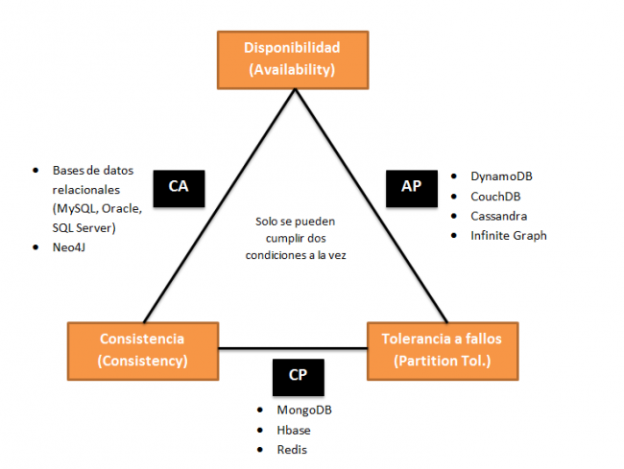

### Modelos de Consistencia

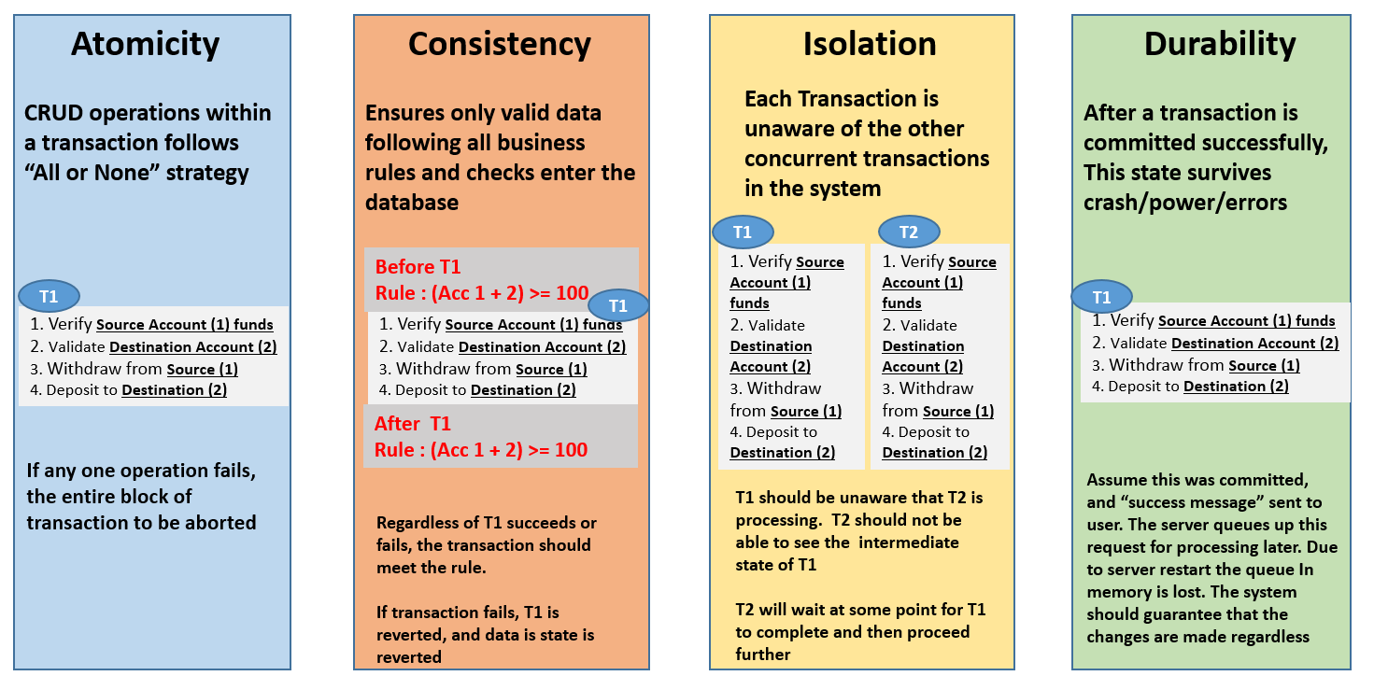

In the NoSQL world, ACID transactions are less fashionable as some databases have loosened the requirements for immediate consistency, data freshness and accuracy in order to gain other benefits, like scale and resilience.

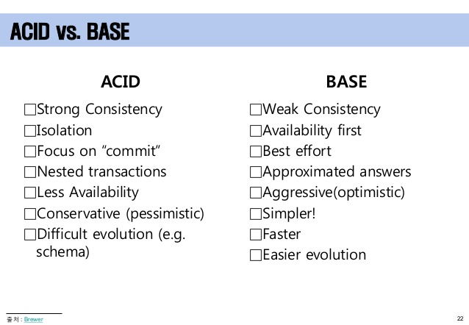

### Categorías

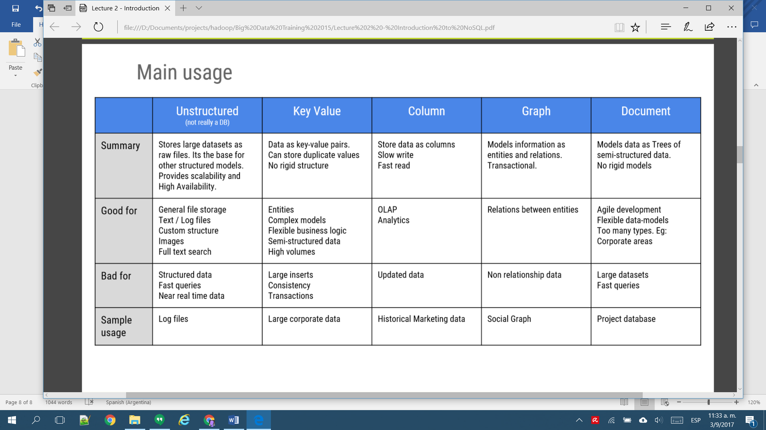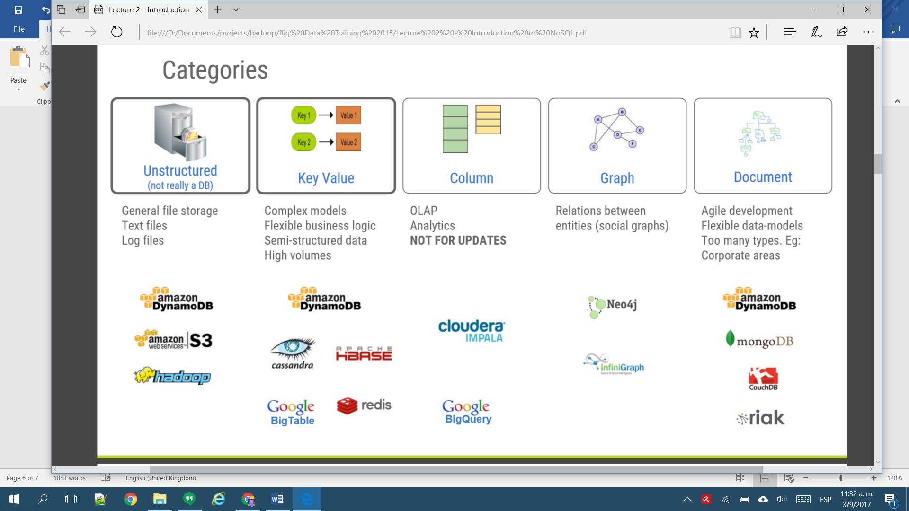

**Replication** - The strategy of duplicating data across more than one node. There are many varieties, simplest being Master-Slave(s) or Leader-Follower and can either be synchronous or asynchronous. Copying an entire table or database onto multiple servers. Used for improving speed of access to reference records such as master data.

**Partitioning** - Splitting up a large monolithic database into multiple smaller databases based on data cohesion. Example - splitting a large ERP database into modular databases like accounts database, sales database, materials database etc. Really just a generic term for dividing a single data set into smaller sets. There are many ways to do this, including sharding and clustering. It can also be single node, such splitting or fragmenting databases and tables into subsets to decrease index size for example.

**Clustering** - There are a couple ways to define this term. One, as the other responders note, is dealing with application servers. However, in database terms, clustering is another subset of partitioning, similar to sharding, though the nodes are aware of each other and function as a unit. Data typically is distributed automatically and rebalanced automatically. Using multiple application servers to access the same database. Used for computation intensive, parallelized, analytical applications that work on non-volatile data.

**Sharding** - Splitting up a large table of data horizontally i.e. row-wise. A table containing 100s of millions of rows may be split into multiple tables containing 1 million rows each. Each of the tables resulting from the split will be placed into a separate database/server. Sharding is done to spread load and improve access speed. Facebook/twitter tables fit into this category. A subset of partitioning, meaning to horizontally partition, typically across independent nodes. Often, data is sharded by a shared key to ensure data locality. Typically, nodes are unaware of each other and are more resilient to failures of their siblings.

From a database perspective, clustering is when you have a group of machines (nodes) hosting the same database schema on the same database software with some form of data exchange between these machines. From outside of the cluster, these machines are seen as a single unit containing a union of the data that is spread across the nodes in the cluster. When your application accesses a cluster, the request is ultimately routed to a single node in the cluster for read or write operation.

Replication is a form of clustering where all nodes in the cluster have the same/identical schema and data. This is useful in the following scenarios:

1. To have high availability of data. Even if a node goes down, the data is still available from other nodes in the cluster.
2. Separate nodes for write and read. Data is replicated from the write cluster to all read clusters. This ensures that under high transaction volumes, the read operations are not getting delayed by write operations and vice-versa.
3. Multiple nodes for read operations and for write operations. This ensures that the read and the write operations are load balanced across multiple nodes resulting in higher scalability and data throughput.

Sharding and Partitioning are essentially the same cluster topology. All nodes in the cluster have identical schema, however the data is divided across nodes such that each node has only a subset of the data. No two nodes will have the same data. Sharding has its use in the following scenarios:

1. Each database node has an upper limit to the amount of data it can store. This limited is usually due to hardware configuration. For example, a node that has a 4TB hard disk attached, can store up to a maximum of 4TB of data. If the total volume of data exceeds this limit, it has to be sharded.
2. Suppose your dataset has 500 million records (rows) for a given table. In a replicated setup, when you fire a query against this table, it is executed in a single node for all 500 million records. In a sharded setup, the query would be split-up across shards and executed. This would be faster since a. the amount of records to query in each shard would be much lesser than 500 million and b. the queries across shards will be executed in parallel.

Of course, sharding is a much more complex setup than clustering. Apart from database platform support it would also require effort in schema design for identifying/introducing a shard key that would be used to split/join data across the shards. The shard key must be chosen such that data is distributed equally across all shards, which may not be easy to determine under certain scenarios.

Also note that in the interest of high availability, it is a common practice to have each shard replicated across more than one node, thereby adding another level of complexity to the cluster topology.

#### Sharding

A database shard is a horizontal partition of data in a database or search engine. Each individual partition is referred to as a shard or database shard. Each shard is held on a separate database server instance, to spread load.

Some data within a database remains present in all shards, but some appears only in a single shard. Each shard (or server) acts as the single source for this subset of data.

Horizontal partitioning is a database design principle whereby rows of a database table are held separately, rather than being split into columns (which is what normalization and vertical partitioning do, to differing extents). Each partition forms part of a shard, which may in turn be located on a separate database server or physical location.

There are numerous advantages to the horizontal partitioning approach. Since the tables are divided and distributed into multiple servers, the total number of rows in each table in each database is reduced. This reduces index size, which generally improves search performance. A database shard can be placed on separate hardware, and multiple shards can be placed on multiple machines. This enables a distribution of the database over a large number of machines, greatly improving performance. In addition, if the database shard is based on some real-world segmentation of the data (e.g., European customers v. American customers) then it may be possible to infer the appropriate shard membership easily and automatically, and query only the relevant shard.

Disadvantages include:

* A heavier reliance on the interconnect between servers
* Increased latency when querying, especially where more than one shard must be searched.
* Data or indexes are often only sharded one way, so that some searches are optimal, and others are slow or impossible.
* Issues of consistency and durability due to the more complex failure modes of a set of servers, which often result in systems making no guarantees about cross-shard consistency or durability.
* Increased complexity of SQL - Increased bugs because the developers have to write more complicated SQL to handle sharding logic.
* Sharding introduces complexity - The sharding software that partitions, balances, coordinates, and ensures integrity can fail.
* Single point of failure - Corruption of one shard due to network/hardware/systems problems causes failure of the entire table.
* Failover servers more complex - Failover servers must themselves have copies of the fleets of database shards.
* Backups more complex - Database backups of the individual shards must be coordinated with the backups of the other shards.
* Operational complexity added - Adding/removing indexes, adding/deleting columns, modifying the schema becomes much more difficult.

Sharding is related to a shared nothing architecture—once sharded, each shard can live in a totally separate logical schema instance / physical database server / data center / continent. There is no ongoing need to retain shared access (from between shards) to the other unpartitioned tables in other shards.

This makes replication across multiple servers easy (simple horizontal partitioning does not). It is also useful for worldwide distribution of applications, where communications links between data centers would otherwise be a bottleneck.



# Hadoop

Apache Hadoop es un framework de software que soporta aplicaciones distribuidas bajo una licencia libre. ​Permite a las aplicaciones trabajar con miles de nodos y petabytes de datos. Hadoop se inspiró en los documentos Google para MapReduce y Google File System (GFS).

The Apache™ Hadoop® project develops open-source software for reliable, scalable, distributed computing.

The Apache Hadoop software library is a framework that allows for the distributed processing of large data sets across clusters of computers using simple programming models. It is designed to scale up from single servers to thousands of machines, each offering local computation and storage. Rather than rely on hardware to deliver high-availability, the library itself is designed to detect and handle failures at the application layer, so delivering a highly-available service on top of a cluster of computers, each of which may be prone to failures.

* **Hadoop Common**: The common utilities that support the other Hadoop modules.
* **Hadoop Distributed File System (HDFS)**: A distributed file system that provides high-throughput access to application data.
* **Hadoop YARN**: A framework for job scheduling and cluster resource management.
* **Hadoop MapReduce**: A YARN-based system for parallel processing of large data sets.

Other Hadoop-related projects at Apache include:

**Ambari**: A web-based tool for provisioning, managing, and monitoring Apache Hadoop clusters which includes support for Hadoop HDFS, Hadoop MapReduce, Hive, HCatalog, HBase, ZooKeeper, Oozie, Pig and Sqoop. Ambari also provides a dashboard for viewing cluster health such as heatmaps and ability to view MapReduce, Pig and Hive applications visually alongwith features to diagnose their performance characteristics in a user-friendly manner.

**Avro**: A data serialization system.

**Cassandra**: A scalable multi-master database with no single points of failure.

**Chukwa**: A data collection system for managing large distributed systems.

**HBase**: A scalable, distributed database that supports structured data storage for large tables.

**Hive**: A data warehouse infrastructure that provides data summarization and ad hoc querying.

**Mahout**: A Scalable machine learning and data mining library.

**Pig**: A high-level data-flow language and execution framework for parallel computation.

**Spark**: A fast and general compute engine for Hadoop data. Spark provides a simple and expressive programming model that supports a wide range of applications, including ETL, machine learning, stream processing, and graph computation.

**Tez**: A generalized data-flow programming framework, built on Hadoop YARN, which provides a powerful and flexible engine to execute an arbitrary DAG of tasks to process data for both batch and interactive use-cases. Tez is being adopted by Hive™, Pig™ and other frameworks in the Hadoop ecosystem, and also by other commercial software (e.g. ETL tools), to replace Hadoop™ MapReduce as the underlying execution engine.

**ZooKeeper**: A high-performance coordination service for distributed applications.

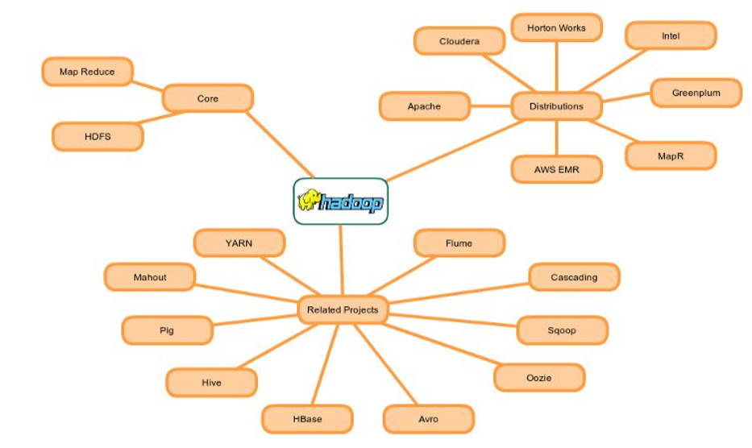

### Hadoop Common

Hadoop consiste básicamente en el **Hadoop Common**, que proporciona acceso a los sistemas de archivos soportados por Hadoop. El paquete de software The Hadoop Common contiene los archivos .jar y los scripts necesarios para ejecutar Hadoop. El paquete también proporciona código fuente, documentación, y una sección de contribución que incluye proyectos de la Comunidad Hadoop.

Una funcionalidad clave es que para la programación efectiva de trabajo, cada sistema de archivos debe conocer y proporcionar su ubicación: el nombre del rack (más precisamente, del switch) donde está el nodo trabajador. Las aplicaciones Hadoop pueden usar esta información para ejecutar trabajo en el nodo donde están los datos y, en su defecto, en el mismo rack/switch, reduciendo así el tráfico de red troncal (backbone traffic). El sistema de archivos HDFS usa esto cuando replica datos, para intentar conservar copias diferentes de los datos en racks diferentes. El objetivo es reducir el impacto de un corte de energía de rack o de fallo de interruptor de modo que incluso si se producen estos eventos, los datos todavía puedan ser legibles.

Un clúster típico Hadoop incluye un nodo maestro y múltiples nodos esclavo. El nodo maestro consiste en jobtracker (rastreador de trabajo), tasktracker (rastreador de tareas), namenode (nodo de nombres), y datanode (nodo de datos). Un esclavo o compute node (nodo de cómputo) consisten en un nodo de datos y un rastreador de tareas. Hadoop requiere tener instalados entre nodos en el clúster JRE 1.6 o superior, y SSH.

* Hadoop Architecture distributes data across the cluster nodes by splitting it into small blocks (64 MB or 128 MB depending upon the configurations). Every node tries to work on individual block stored locally. Hence no data transfer is required during the processing most of the time.
* Every time when Hadoop process the data, each node connects to other node as much less as possible. So most of the time node only deals with the data which is stored locally. This concept is known as “Data Locality”.
* As we know data is distributed across the nodes, so in order to increase data availability each block of the data is replicated (as per the configuration) over different nodes. This method would help Hadoop to handle partial failures in the cluster.
* Whenever MapReduce job (consist to typically two tasks Map Task and Reduce Task) is executed, Map tasks are executed on individual data blocks on each node (in most of the cases) and leverage “Data Locality”. This is how multiple nodes process data in parallel manner. It makes processing faster than traditional distributed systems. I’ll Explain you MapReduce in my upcoming posts.
* If any node fails in between, the master will detect this failure and assign the same task to another node where the replica of the same data block is available.
* If any failed node restarts, it automatically joins back to the cluster and than after master can assign it a new task whenever is required.
* In the execution process of any job, if master detects any task running slowly on any node compare to other nodes, it will allocate the same redundant task on other node to make overall execution faster. This process is known as “***Speculative Execution***“
* The Hadoop jobs are written in a high level language like Java and Python, and the developer do not have any control over network programming or component level programming. You just have to focus on core logic other things would be taken care by Hadoop framework itself.

### Hadoop Distributed File System

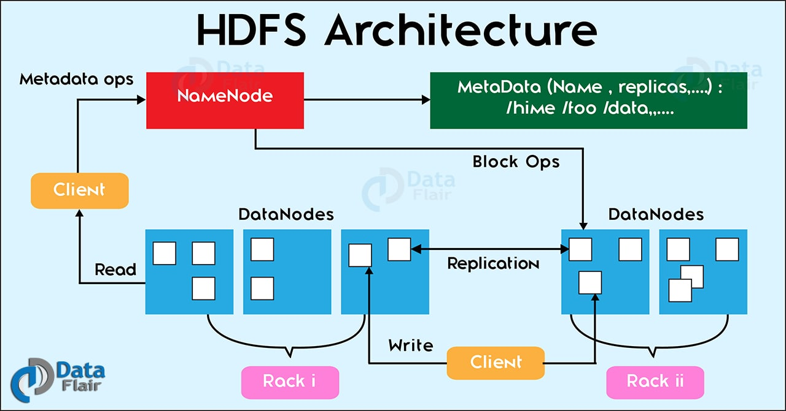

El Hadoop Distributed File System (HDFS) es un sistema de archivos distribuido, escalable y portátil escrito en Java para el framework Hadoop. Cada nodo en una instancia Hadoop típicamente tiene un único nodo de datos; un clúster de datos forma el clúster HDFS. La situación es típica porque cada nodo no requiere un nodo de datos para estar presente. Cada nodo sirve bloques de datos sobre la red usando un protocolo de bloqueo específico para HDFS. El sistema de archivos usa la capa TCP/IP para la comunicación; los clientes usan RPC para comunicarse entre ellos.

HDFS almacena archivos grandes (el tamaño ideal de archivo es de 64 MB​), a través de múltiples máquinas. Consigue fiabilidad mediante replicado de datos a través de múltiples hosts, y no requiere almacenamiento RAID en ellos. Con el valor de replicación por defecto, 3, los datos se almacenan en 3 nodos: dos en el mismo rack, y otro en un rack distinto. Los nodos de datos pueden hablar entre ellos para reequilibrar datos, mover copias, y conservar alta la replicación de datos. HDFS no cumple totalmente con POSIX porque los requerimientos de un sistema de archivos POSIX difieren de los objetivos de una aplicación Hadoop, porque el objetivo no es tanto cumplir los estándares POSIX sino la máxima eficacia y rendimiento de datos. HDFS fue diseñado para gestionar archivos muy grandes. HDFS no proporciona Alta disponibilidad.

HDFS is a distributed file system which stores the data in distributed manner. Rather than storing a complete file it divides a file into small blocks (of 64 or 128 MB size) and distributes them across the cluster. Each blocks is replicated (3 times as per default configuration) multiple times and is stored on different nodes to ensure data availability. Normally HDFS can be installed on native file systems like xfs, ext3 or ext4 (Similar to Unix/Linux file systems).

Otros sistemas de archivos

A junio de 2010, la lista de sistemas de archivos soportados incluye:

HDFS: El sistema propio de Hadoop. Está diseñado para la escala de decenas petabytes de almacenamiento y funciona sobre los sistemas de archivos de base.

Amazon S3. Éste se dirige a clusters almacenados en la infraestructura del servidor bajo demanda Amazon Elastic Compute Cloud. No hay conciencia de racks en este sistema de archivos, porque todo él es remoto.

CloudStore (previamente llamado Kosmos Distributed File System), el cual es consciente de los racks.

FTP: éste almacena todos sus datos en un servidor FTP accessible remotamente.

HTTP y HTTPS de solo lectura.

Hadoop puede trabajar directamente con cualquier sistema de archivos distribuido, el cual puede ser montado por el sistema operativo subyacente simplemente usando la URL file://, sin embargo esto tiene un precio: la pérdida de la localidad. Para reducir el tráfico de red, Hadoop necesita saber qué servidores están más próximos a los datos; esta información la pueden proporcionar los puentes específicos del sistema de archivos específico de Hadoop.

### MapReduce

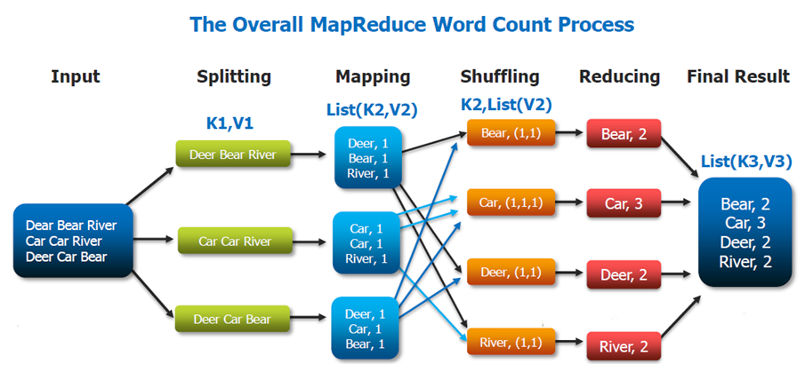

MapReduce is the algorithm of executing any task on distributed system. Using MapReduce one can process a large file in parallel manner. MapReduce framework executes any task on different nodes as full file is distributed across the cluster in a form of various blocks.

It has two phases, Map(Mapper Task) and Reduce (Reducer Task)

* Each of these tasks would run on individual blocks of the data
* First mapper task would take each line of elements as an input and generates intermediate key value pairs
* Each mapper task is executed on a single block of data
* Than reducer task will take list of key value pairs for same keys, process the data and generates the final output
* A phase called shuffle and sort will take place between mapper and reducer task will send the data to proper reducer tasks
* Shuffle process maps the mapper output with the same key to the collection of values as a value
  + For example (key1, val1) and (key1, val2) will be converted to (key1, [val1, val2])
* The mapper and reducer tasks would in parallel
* The reducer tasks can start their word as soon as mapper tasks are completed

### Hadoop versions

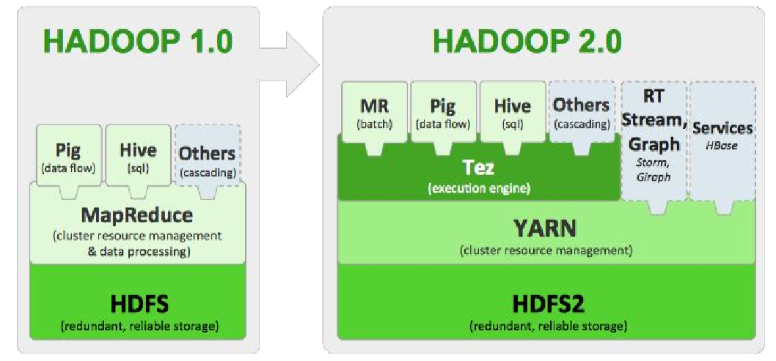

#### **Hadoop version 1**

##### HDFS

HDFS in Hadoop 1.x mainly has 3 daemons which are Name Node, Secondary Name Node and Data Node.

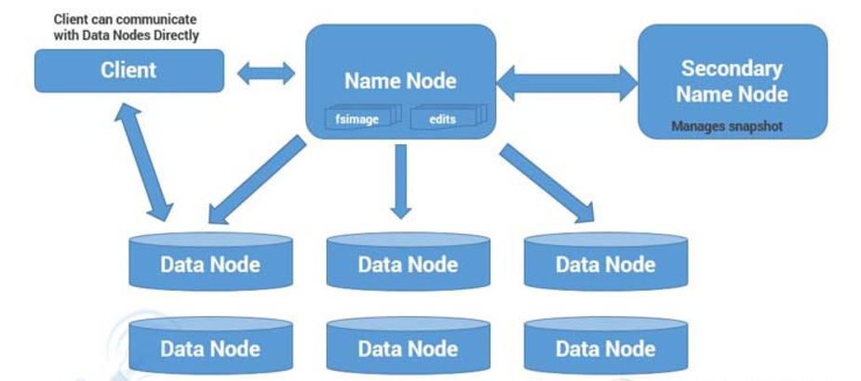

**Name Node**

* There is only single instance of this process runs on a cluster and that is on a master node
* It is responsible for manage metadata about files distributed across the cluster
* It manages information like location of file blocks across cluster and it’s permission
* This process reads all the metadata from a file named fsimage and keeps it in memory
* After this process is started, it updates metadata for newly added or removed files in RAM
* It periodically writes the changes in one file called edits as edit logs
* This process is a heart of HDFS, if it is down HDFS is not accessible any more

**Secondary Name Node**

* For this also, only single instance of this process runs on a cluster
* This process can run on a master node (for smaller clusters) or can run on a separate node (in larger clusters) depends on the size of the cluster
* One misinterpretation from name is *“This is a backup Name Node”* but **IT IS NOT!!!!!**
* It manages the metadata for the Name Node. In the sense, it reads the information written in edit logs (by Name Node) and creates an updated file of current cluster metadata
* Than it transfers that file back to Name Node so that fsimage file can be updated
* So, whenever Name Node daemon is restarted it can always find updated information in fsimage file

**Data Node**

* There are many instances of this process running on various slave nodes(referred as Data nodes)
* It is responsible for storing the individual file blocks on the slave nodes in Hadoop cluster
* Based on the replication factor, a single block is replicated in multiple slave nodes(only if replication factor is > 1) to prevent the data loss
* Whenever required, this process handles the access to a data block by communicating with Name Node
* This process periodically sends heart bits to Name Node to make Name Node aware that slave process is running

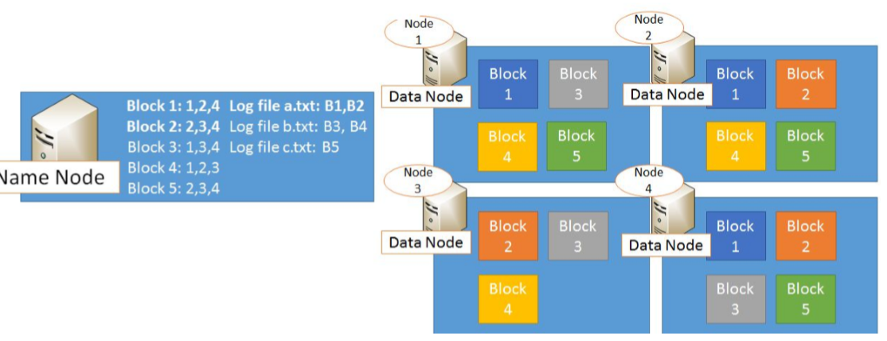

**Single Point Of Failure**: As per above description, HDFS has only one Name Node so if that process or machine goes down complete cluster goes down. That is why Name Node in Hadoop 1.x is considered to be a Single Point of Failure.

Blocks are the nothing but the smallest continuous location on your hard drive where data is stored. In general, in any of the File System, you store the data as a collection of blocks. Similarly, HDFS stores each file as blocks which are scattered throughout the Apache Hadoop cluster. The default size of each block is 128 MB in Apache Hadoop 2.x (64 MB in Apache Hadoop 1.x) which you can configure as per your requirement.

![HDFS ARCHITECTURE – HDFS TUTORIAL Introduction In this blog, we are going to talk about HDFS Architecture. From my previous blog, we already know that HDFS is a distributed file system which is deployed on low cost commodity hardware. I discussed many of its features too. So, its high time that we take a deep dive into Apache Hadoop HDFS Architecture and unlock its beauty. The topics that will be covered in this blog are as follows: • HDFS Master/Slave Topology • NameNode and DataNode • What is a block • Replication Management • Rack Awareness • HDFS Read/Write – Behind the scenes HDFS Architecture HDFS or Hadoop Distributed File System is a block-structured file system where each file is divided into blocks of a pre-determined size. These blocks are stored across a cluster of one or several machines. Apache Hadoop HDFS Architecture follows a Master/Slave Architecture, where a cluster comprises of a single NameNode (Master node) and all the other nodes are DataNodes (Slave nodes). HDFS is based on Java programming language, due to which HDFS can be deployed on broad spectrum of machines that support Java. Though one can run several DataNodes on a single machine, but in practical world, these DataNodes are spread across various machines. NameNode and DataNode NameNode: NameNode is the master of HDFS that maintains and manages the blocks present on the DataNodes (slave nodes). Think of the NameNode as a Lamborghini in midst of various other cars. Thus, like a Lamborghini, NameNode is a very highly available server that manages the File System Namespace and controls access to files by clients. I will be discussing this High Availability feature of Apache Hadoop HDFS in my next blog. The HDFS architecture is built in such a way that the user data is never stored in the NameNode. The data resides on DataNodes only. Functions of NameNode: • It is the master daemon that maintains and manages the DataNodes (slave nodes) • It records the metadata of all the files stored in the cluster, e.g. location of blocks stored, size of the files, permissions, hierarchy, etc. There are two files associated with metadata: o FsImage: An image of the file system on starting the NameNode. o EditLogs: A series of modifications done to the file system after starting the NameNode. • It records each change that takes place to the file system metadata. For example, if a file is deleted in HDFS, the NameNode will immediately record this in the EditLog. • It regularly receives a Heartbeat and a block report from all the DataNodes in the cluster to ensure that the DataNodes are live. • It keeps a record of all the blocks in HDFS and in which nodes these blocks are located. • The NameNode is also responsible to take care of the replication factor of all the blocks which we will discuss in detail later in this HDFS tutorial blog. • In case of a DataNode failure, the NameNode chooses new DataNodes for new replicas, balances disk usage and manages the communication traffic to the DataNodes. DataNode: DataNodes are the slave nodes in HDFS, just like any average car in front of a Lamborghini! Unlike NameNode, DataNode is a commodity hardware, that is, a non-expensive system which is not of high quality or high-availability. DataNode is a block server that stores the data in the local file ext3 or ext4. Functions of DataNode: • These are slave daemons or process which runs on each slave machine. • The actual data is stored on DataNodes. • DataNodes perform the low-level read and write requests from the file system’s clients. • They send heartbeats to the NameNode periodically to report the overall health of HDFS, by default, this frequency is set to 3 seconds. So, till now, you folks must have realized that the NameNode is pretty much important to us. If it fails, we are doomed. But don’t worry, we will be talking about how Hadoop solved this single point of failure problem in the next HDFS tutorial blog. So, just relax for now and let’s take one step at a time. Secondary NameNode Apart from these two daemons there is a third daemon or process called Secondary NameNode. The Secondary NameNode works concurrently with the primary NameNode as a helper daemon. And don’t confuse Secondary NameNode as a backup NameNode because it is not. Functions of Secondary NameNode: • The Secondary NameNode is one which constantly reads all the file systems and metadata from the RAM of the NameNode and writes it into the hard disk or the file system. • It is responsible for combining the EditLogs with FsImage from the NameNode. • It downloads the EditLogs from the NameNode at regular intervals and applies to FsImage. The new FsImage is copied back to the NameNode, which is used whenever the NameNode is started the next time. Hence, Secondary NameNode just performs regular checkpoints in HDFS. Therefore, it is also called CheckpointNode. Blocks Now as we know that the data in HDFS is scattered across the DataNodes as blocks. Let’s have a look on what is a block and how is it formed? Blocks are the nothing but smallest continuous location in your hard drive where data is stored. In general, in any of the File System the data are stored as collection of blocks. Similarly, HDFS stores each file as blocks which is scattered throughout the Apache Hadoop cluster. The default size of each block is 128MB in Apache Hadoop 2.x (64 MB in Apache Hadoop 1.x) which you can configure as per your requirement. It is not necessary that in HDFS, each file is stored in exact multiple of the configured block size (128MB, 256MB etc.). Let’s take an example where I have a file “example.txt” of size 514MB as shown in above figure. Suppose, we are using the default block size configuration which is 128Mb. So, how many blocks will be created? 5, Right. First four blocks will be of 128 MB. But, the last block will be of 2 MB size only. Now you must be thinking why we need to have such a huge blocks size i.e. 128MB? Well, whenever we talk about HDFS, we talk about huge data sets i.e. terabytes and petabytes of data. So, if we had a block size of let’s say 4KB as in Linux file system, we would be having too many of blocks and therefore too much of metadata. So, managing these no. of blocks and metadata will create huge overhead which is something, we don’t want. As you understood what a block is, lets understand how these blocks are places in the next section. Replication Management and Rack Awareness Replication Management: HDFS provides a reliable way to store huge data in a distributed environment as data blocks. The blocks are also replicated to provide fault tolerance. The default replication factor is 3 which is again configurable. So, if you want to store a file of 1GB in your HDFS, you will be consuming a space of 3GB (replication factor =3) and 24 (1GB/128MB=8 data blocks) data blocks in total, considering the default configuration. Don’t worry guys, if you didn’t get the math in one go. Take your time then move ahead. The NameNode collects block report from DataNode periodically to maintain the replication factor. Therefore, whenever a block is over-replicated or under-replicated the NameNode deletes or add replicas as needed. Rack Awareness: Anyways, moving ahead, let’s talk more about how replica are placed and what is rack awareness? Again, the NameNode also ensures that all the replicas are not stored on the same rack or a single rack. It follows an in-built Rack Awareness Algorithm to reduce latency. Considering the replication factor is 3, the Rack Awareness Algorithm says that the first replica of a block will be stored on a local rack and the next two replicas will be stored on a different (remote) rack but on a different DataNode within that (remote) rack. If you have more replicas, the rest of the replicas will be placed on random DataNodes provided not more than two replicas reside on the same rack, if possible. This is how an actual Hadoop production cluster looks like. Here, you have multiple racks populated with many DataNodes. Advantages of Rack Awareness: So now you will be thinking why do we need Rack Awareness algorithm? The reasons are: • To improve the network performance: The communication between nodes residing on different racks is directed via switch. In general, you will find greater network bandwidth between machines in the same rack than the machines residing in different rack. So, the Rack Awareness helps you to have reduce write traffic in between different racks and thus providing a better write performance. Also, you will be gaining increased read performance because you are using the bandwidth of multiple racks. • To prevent loss of data: We don’t have to worry about the data even if an entire rack fails because of the switch failure or power failure. And if you think about it, it will make sense, as it is said that never put all your eggs in the same basket. HDFS Read/ Write Architecture Now let’s talk about how the data read/write operations are performed on HDFS. HDFS follows Write Once - Read Many philosophy. So, you can’t edit files already stored in HDFS. But, you can append new data in a file. HDFS Write Architecture: Imagine a situation where a HDFS client, want to write a file named “example.txt” of size 248MB. Assume that the system block size is configured to 128 MB (default). So, the client will be dividing the file “example.txt” into 2 blocks – one of 128MB (Block A) and the other of 120 MB (block B). Now, the following protocol will be followed whenever the data is written into HDFS: • At first, the HDFS client will reach out to the NameNode for a Write Request against the two blocks, say, Block A & Block B. • The NameNode will then grant client the write permission and will provide the IP addresses of the DataNodes where the file blocks will be copied eventually. • The selection of IP addresses of DataNodes is purely randomized based on availability, replication factor and rack awareness that we have discussed earlier. • Let’s say the replication factor is set to default i.e. 3. Therefore, for each block the NameNode will be providing the client a list of (3) IP addresses of DataNodes. The list will be unique for each block. • Suppose, the NameNode provided following lists of IP addresses to the client: o For Block A, list A = {IP of DataNode 1, IP of DataNode 4, IP of DataNode 5} o For Block B, set B = {IP of DataNode 3, IP of DataNode 7, IP of DataNode 9} • Each block will be copied in three different DataNodes to maintain the replication factor consistent. • Now the whole data copy process will happen in three stages: 1. Set up of Pipeline 2. Data streaming and replication 3. Shutdown of Pipeline (Acknowledgement stage) 1. Set up of Pipeline: Before writing the blocks, client confirms whether the DataNodes present in each of the list of IPs are ready to receive the data or not. For doing so, the client creates a pipeline for each of the blocks by connecting the individual DataNodes in the respective list for that block. Let us consider Block A. The list of DataNodes provided by the NameNode is : For Block A, list A = {IP of DataNode 1, IP of DataNode 4, IP of DataNode 5}. So, for block A, the client will be performing following steps to create a pipeline: ➢ Client will choose first DataNode in the list (DataNode IPs for Block A) which is DataNode 1 and will open a TCP/IP connection. ➢ Client will inform DataNode 1 to be ready to receive the block. It will also provide the IPs of next two DataNodes (4 and 5) where the block will be replicated. ➢ DataNode 1 will connect to DataNode 4. DataNode 1 will inform DataNode 4 to be ready to receive the block and will give it the IP of DataNode 5. Then, DataNode 4 will tell DataNode 5 to be ready for receiving the data. ➢ Next, the acknowledgement of readiness will follow the reverse sequence i.e. From DataNode 5 to 4 and then to 1. ➢ At last DataNode 1 will inform the client that all the DataNodes are ready and a pipeline is formed between client, DataNode 1, 4 and 5. ➢ Now pipeline set up is complete and the client will finally begin the data copy or streaming process. 2. Data Streaming: As the pipeline has been created, the client will push the data into the pipeline. Now, don’t forget that in HDFS, data is replicated based on replication factor. So, here Block A will be stored to three DataNodes as the assumed replication factor is 3. Moving ahead, the client will copy the block (A) to DataNode 1 only. The replication is always done by DataNodes sequentially. So, following steps will take place during replication: ➢ Once the block has been written to DataNode 1, it will connect to DataNode 4. ➢ Then, it will push the block in the pipeline and data will be copied to DataNode 4. ➢ Again, DataNode 4 will connect to DataNode 5 and will copy the block. 3. Shutdown of Pipeline or Acknowledgement stage: Once the block has been copied into all the three DataNodes, a series of acknowledgements will take place to ensure the client and NameNode that the data has been written successfully. And client will finally close the pipeline to end the TCP session. As shown in the figure, the acknowledgement happens in the reverse sequence i.e. from DataNode 5 to 4 and then to 1. Finally, the DataNode 1 will push three acknowledgements (including its own) into the pipeline and send it to client. Client will inform NameNode that data has been written successfully. NameNode will update its metadata and the client will shut down the pipeline. Similarly, Block B will also be copied into the DataNodes in parallel with Block A. But, following things are to be noticed here: ➢ Client will copy Block A and Block B to the first DataNode simultaneously. ➢ Therefore, in our case two pipelines will be formed for each of the block and all the process discussed above will happen in parallel in these two pipelines. ➢ Client writes the block into first DataNode and then the DataNodes will be replicating the block sequentially. Folks! Its time for a quiz now: In HDFS, blocks of a file are written in parallel, however the replication of the blocks are done sequentially: a. True b. False True. Right guys. So, if you are still confused, go through the HDFS write architecture again. I am sure you will understand it this time. HDFS Read Architecture: HDFS Read architecture is comparatively easy to understand. Let’s the above example again where a HDFS clients want to read the file “example.txt” which is already there in HDFS. Now, following steps will be taking place while reading the file: • Client will reach out to NameNode asking for the block metadata for the file example.txt. • The NameNode will return the list of DataNodes where each block (Block A and B) are stored. • After that client, will connect to the DataNodes where the blocks are stored. • Client starts reading data parallel from the Data nodes (Block A from DataNode 1 and Block B from DataNode 5). • Once it gets all the required file blocks, it will combine these blocks to form a file. While serving read request of the client, HDFS selects the replica which is closest to the client. This reduces the read latency and the bandwidth consumption. Therefore, that replica is selected which resides on the same rack as the reader node, if possible. ](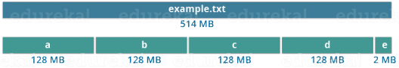)

It is not necessary that in HDFS, each file is stored in exact multiple of the configured block size (128 MB, 256 MB etc.). Let’s take an example where I have a file “example.txt” of size 514 MB as shown in above figure.  Suppose that we are using the default configuration of block size, which is 128 MB. Then, how many blocks will be created? 5, Right. The first four blocks will be of 128 MB. But, the last block will be of 2 MB size only.

**Now, you must be thinking why we need to have such a huge blocks size i.e. 128 MB?**

Well, whenever we talk about HDFS, we talk about huge data sets, i.e. Terabytes and Petabytes of data. So, if we had a block size of let’s say of 4 KB, as in Linux file system, we would be having too many blocks and therefore too much of the metadata. So, managing these no. ofblocks and metadata will create huge overhead, which is something, we don’t want.

##### MapReduce

MapReduce component is responsible for distributed computing on Hadoop Cluster. Basically it uses two daemons named Job Tracker and Task Tracker. Hadoop MapReduce algorithm basically has two phases Map and Reduce

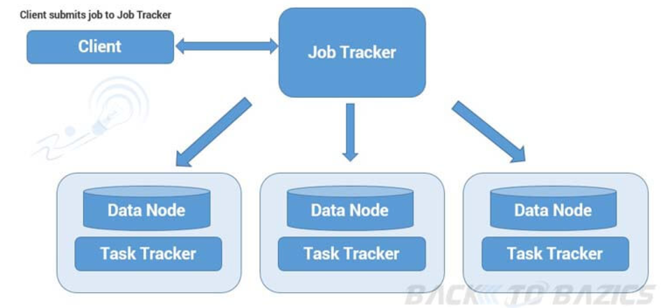

**Job Tracker**

* Only one instance of this process runs on a master node same as Name Node
* Any MapReduce job is submitted to Job Tracker first
* Job Tracker checks for the location various file blocks used in MapReduce processing
* Than it initiates the separate tasks on various Data Nodes(where blocks are present) by communicating with Task Tracker Daemons

**Task Tracker**

* This process has multiple instances running on the slave nodes(typically runs on the slave nodes where Data Node process is running)
* It receives the job information from Job Tracker daemon and initiates a task on that slave node
* In most of the cases, Task Tracker initiates the task on the same node where there physical data block is present
* Same as Data Node daemon, this process also periodically sends heart bits to Job Tracker to make Job Tracker aware that slave process is running

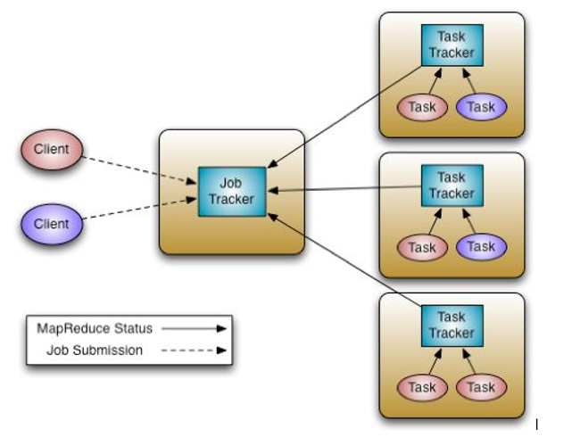

##### Limitations of Hadoop 1.x Architecture

As we also have seen in above description, major drawback of Hadoop 1.x Architecture is Single Point of Failure as there is no backup Name Node.

Job scheduling, resource management and job monitoring are being done by Job Tracker which is tightly coupled with Hadoop. So Job Tracker is not able to manage resources outside Hadoop.

Job Tracker has to coordinate with all task tracker so in a very big cluster it will be difficult to manage huge number of task trackers altogether.

Due to single Name Node, there is no concept of namespaces in Hadoop 1.x. So everything is being managed under single namespace.

Using Hadoop 1.x architecture, Hadoop Cluster can be scaled upto ~4000 nodes. Scalablity beyond that may cause performance degradation and increasing task failure ratio.

#### **Hadoop version 2**

* Hadoop 2.x has some common Hadoop API which can easily be integrated with any third party applications to work with Hadoop
* It has some new Java APIs and features in HDFS and MapReduce which are known as HDFS2 and MR2 respectively
* New architecture has added the architectural features like HDFS High Availability and HDFS Federation
* Hadoop 2.x not using Job Tracker and Task Tracker daemons for resource management now on-wards, it is using YARN (Yet Another Resource Negotiator) for Resource Management

##### HDFS High Availability (HA)

**Problem:**  As you know in Hadoop 1.x architecture Name Node was a single point of failure, which means if your Name Node daemon is down somehow, you don’t have access to your Hadoop Cluster than after. How to deal with this problem?

**Solution:**  Hadoop 2.x is featured with Name Node HA which is referred as HDFS High Availability (HA).

* Hadoop 2.x supports two Name Nodes at a time one node is active and another is standby node
* Active Name Node handles the client operations in the cluster
* StandBy Name Node manages metadata same as Secondary Name Node in Hadoop 1.x
* When Active Name Node is down, Standby Name Node takes over and will handle the client operations then after
* HDFS HA can be configured by two ways
  + Using Shared NFS Directory
  + Using Quorum Journal Manager

##### HDFS Federation

**Problem:**  HDFS uses namespaces for managing directories, file and block level information in cluster. Hadoop 1.x architecture was able to manage only single namespace in a whole cluster with the help of the Name Node (which is a single point of failure in Hadoop 1.x). Once that Name Node is down you loose access of full cluster data. It was not possible for partial data availability based on name space.

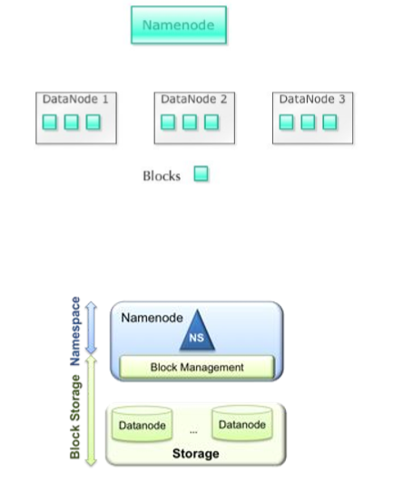

**Solution:**  Above problem is solved by HDFS Federation i Hadoop 2.x Architecture which allows to manage multiple namespaces by enabling multiple Name Nodes. So on HDFS shell you have multiple directories available but it may be possible that two different directories are managed by two active Name Nodes at a time.

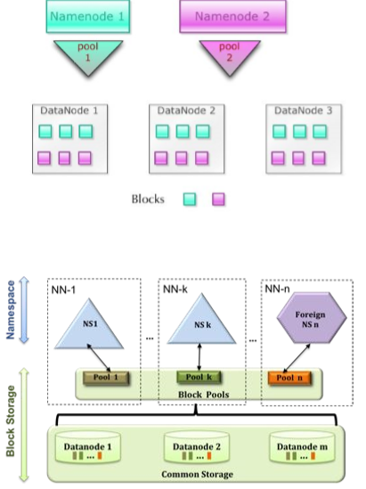

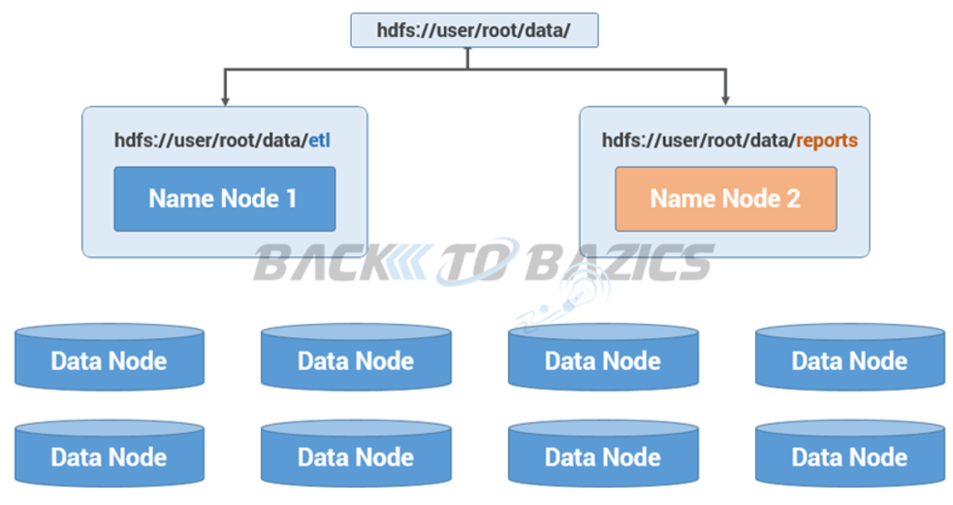

##### Differences version 1 vs version 2

|  |  |
| --- | --- |
| **Hadoop1** | **Hadoop2** |
| Supports MapReduce (MR) processing model only. Does not support non-MR tools | Allows to work in MR as well as other distributed computing models like Spark, Hama, Giraph, Message Passing Interface) MPI & HBase coprocessors. |
| MR does both processing and cluster-resource management. | YARN (Yet Another Resource Negotiator) does cluster resource management and processing is done using different processing models. |
| Has limited scaling of nodes. Limited to 4000 nodes per cluster | Has better scalability. Scalable up to 10000 nodes per cluster |
| Works on concepts of slots – slots can run either a Map task or a Reduce task only. | Works on concepts of containers. Using containers can run generic tasks. |
| A single Namenode to manage the entire namespace. | Multiple Namenode servers manage multiple namespaces. |
| Has Single-Point-of-Failure (SPOF) – because of single Namenode- and in the case of Namenode failure, needs manual intervention to overcome. | Has to feature to overcome SPOF with a standby Namenode and in the case of Namenode failure, it is configured for automatic recovery. |
| MR API is compatible with Hadoop1x. A program written in Hadoop1 executes in Hadoop1x without any additional files. | MR API requires additional files for a program written in Hadoop1x to execute in Hadoop2x. |
| Has a limitation to serve as a platform for event processing, streaming and real-time operations. | Can serve as a platform for a wide variety of data analytics-possible to run event processing, streaming and real-time operations. |
| A Namenode failure affects the stack. | The Hadoop stack – Hive, Pig, HBase etc. are all equipped to handle Namenode failure. |
| Does not support Microsoft Windows | Added support for Microsoft windows |

### Hadoop not good for

1. Low-latency Data Access

Applications that require real-time query, and low-latency access to data in tens of milliseconds will not work well with Hadoop.

Hadoop is not a substitute for a database. Database index records that will gains low-latency and fast response.

But if you really want to replace the database for real time needs, try HBase, which is a column-oriented database for random and real time read/write.

2. Structured Data

Hadoop is not fit for structured data with strong relationship. Hadoop works well for semi-structured and unstructured data. It stores data in files, doesn’t index them like

RDBMS. Therefore, each ad hoc query for Hadoop is processed by MapReduce job which will bring the latency cost.

3. When data isn’t that big

How big the data is big enough for Hadoop? The answer is TB or PB. When your analytics data is only tens of GB, Hadoop is heavy. Don’t follow the fashion and use Hadoop,

just follow your requirements.

4. Too many small files

When there are too many small files, the NameNode will hit its memory limit where the block map and the metadata are hosted. And to handle the NameNode bottleneck,

Hadoop introduces HDFS Federation.

5. MapReduce may not the best choice

MapReduce is a simple programming model in parallel. But for MapReduce parallelism, you need to make sure each MR job and the data where the job runs on is

independent from all the others. Every MR shouldn’t have dependencies.

But if you want to do some data sharing during MR, you can do like this:

- Iteration: run multiple MR jobs, with the output of one being the input of the next MR.

- Shared state information. But don’t share information in memory, since each MR job is run on single JVM.

##### HDFS 2.x Daemons

The working methodology of HDFS 2.x daemons is same as it was in Hadoop 1.x Architecture with following differences.

* Hadoop 2.x allows Multiple Name Nodes for HDFS Federation
* New Architecture allows HDFS High Availability mode in which it can have Active and StandBy Name Nodes (No Need of Secondary Name Node in this case)
* Hadoop 2.x Non HA mode has same Name Node and Secondary Name Node working same as in Hadoop 1.x architecture

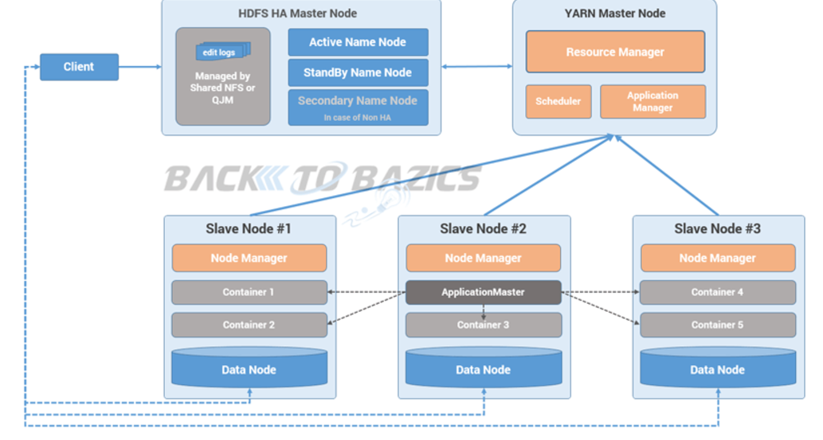

Every HDFS cluster is comprised of one or two NameNodes, and as many DataNodes as your IT budget will allow. What makes a server into a NameNode or a DataNode is an eponymous Java process running as a UNIX daemon on it. What determines whether you are running just one or two NameNodes is your tolerance for HDFS outages. With just one NameNode - if it goes down your whole HDFS deployment is unavailable (even though the DataNodes may be running just fine). With two NameNodes running in an Active/Standby configuration, the Standby can take over in cases where the Active one fails or needs to be brought down for maintenance. This is called a High Availability (HA)

* + **NameNode (one or two per cluster)**  
    - Represents a single filesystem namespace rooted at **/**   
    - Is the master service of HDFS  
    - Determines and maintains how the chunks of data are distributed across the DataNodes  
    - Actual data never resides here, only metadata (e.g., maps of where blocks are distributed).
  + **DataNode (as many as you want per cluster)**  
    - Stores the chunks of data, and is responsible for replicating the chunks across other DataNodes  
    - Default number of replicas on most clusters is 3 (but it can be changed on a per-file basis)  
    - Default block size on most clusters is 128MB.

A default replication factor of 3 for every block is good for two reasons. First of all, this level of replication means you can afford to have one node failing, and still have fault tolerance with two nodes left. Secondly, it allows for the third copy to be placed on a different rack in the datacenter, thus maximizing the chances that at least one copy of the block will survive all major catastrophic events. As such, a replication factor of 3 for every block can be a good starting point to make sure that your mission-critical applications are up and running in crises situations. But, for an extra level of protection (or to make sure that a copy of a block is available locally on all nodes in a data center - thus maximizing the locality of data), it may be better to have a higher level of replication factor configured. The good news is that, with HDFS, you don't have to decide upfront. It allows the configuration of the replication factor on a per-file or a per-folder basis.

##### MapReduce 2.x Daemons (YARN)

MapReduce2 has replace old daemon process Job Tracker and Task Tracker with YARN components Resource Manager and Node Manager respectively. These two components are responsible for executing distributed data computation jobs in Hadoop 2.

In Hadoop 1.x Architecture JobTracker daemon was carrying the responsibility of Job scheduling and Monitoring as well as was managing resource across the cluster. And TaskTracker daemon was executing map reduce tasks on the slave nodes. YARN has divided the responsibilities of JobTracker to two processes ResourceManager and ApplicationMaster and instead of TaskTracker is using NodeManager daemon for map reduce task execution.

Now lets understand the roles ans responsibilities of each and every YARN components.

YARN has total three major components

* ResourceManager
* NodeManager
* ApplicationMaster

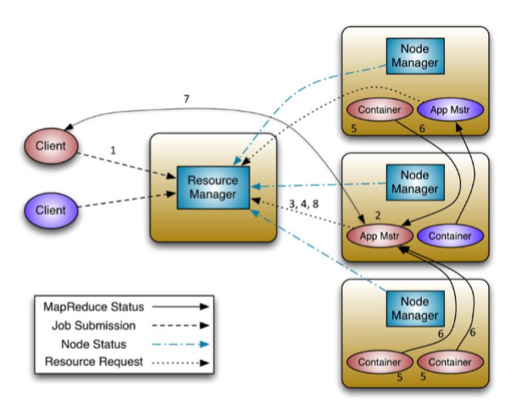

**Resource Manager**

* This daemon process runs on master node (may run on the same machine as name node for smaller clusters)
* It is responsible for getting job submitted from client and schedule it on cluster, monitoring running jobs on cluster and allocating proper resources on the slave node
* It communicates with Node Manager daemon process on the slave node to track the resource utilization
* It uses two other processes named *Application Manager*and *Scheduler*for MapReduce task and resource management

**Scheduler**

* This daemon process resides on the Master Node (runs along with ResourceManager daemon )
* Responsible for,
  + Scheduling the job execution as per submission request received by ResourceManager
  + Allocating resources to applications submitted to the cluster
  + Coordinating with ApplicationManager daemon and keeping track of resources of running applications

**ApplicationManager**

* This daemon process resides on the Master Node (runs along with ResourceManager daemon )
* Responsible for,
  + Helping Scheduler daemon to keeps track of running application by coordination
  + Accepting job submissions from client
  + Negotiating first container for executing application specific task with suitable ApplicationMaster on slave node

**Node Manager**

* This daemon process runs on slave nodes (normally on HDFS Data node machines)
* It is responsible for coordinating with Resource Manager for task scheduling and tracking the resource utilization on the slave node
* It also reports the resource utilization back to the Resource Manager
* It uses other daemon process like Application Master and Container for MapReduce task scheduling and execution on the slave node

**ApplicationMaster**

* This daemon process runs on the slave node (along with the NodeManager daemon)
* It is per application specific library works with NodeManager to execute the task
* The instance of this daemon is per application, which means in case of multiple jobs submitted on cluster, it may have more than one instances of ApplicationMaster on slave nodes
* Responsible for,
  + Negotiating suitable resource containers on slave node from ResourceManager
  + Working with one or multiple NodeManagers to monitor task execution on slave nodes

**Container**

* It is considered to be a small unit of resources (like cpu, memory, disk) belong to the SlaveNode
* Scheduler process running along with ResourceManager daemon allocates the resources as a container
* At the beginning of a job execution with YARN, container allows ApplicationMaster process to make a use of some resources on any slave node on the cluster
* Then ApplicationMaster manages the application execution across other containers on slave nodes of a YARN cluster

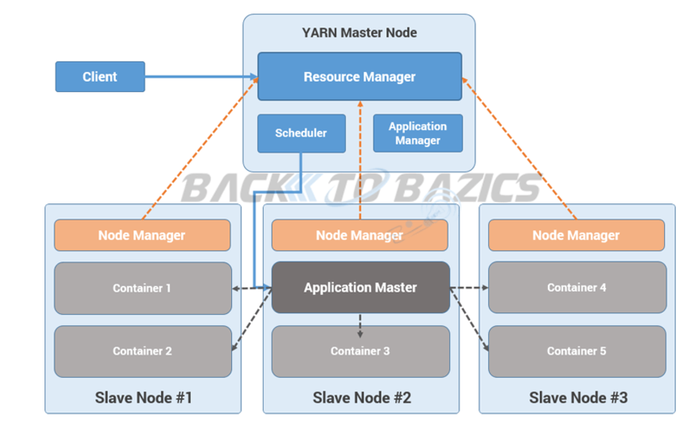

### Run Job process

**Step 1:**  Job/Application(which can be MapReduce, Java/Scala Application, DAG jobs like Apache Spark etc..) is submitted by the YARN client application to the ResourceManager daemon along with the command to start the ApplicationMaster on any container at NodeManager

**Step 2:**  ApplicationManager process on Master Node validates the job submission request and hand it over to Scheduler process for resource allocation

**Step 3:**  Scheduler process assigns a container for ApplicationMaster on one slave node

**Step 4:**  NodeManager daemon starts the ApplicationMaster service within one of its container using the command mentioned in Step 1, hence ApplicationMaster is considered to be the first container of any application

**Step 5:**  ApplicationMaster negotiates the other containers from ResourceManager by providing the details like location of data on slave nodes, required cpu, memory, cores etc..

**Step 6:**  ReourceManager allocates the best suitable resources on slave nodes and responds to ApplicationMaster with node details and other details

**Step 7:**  Then, ApplicationMaster send requests to NodeManagers on suggested slave nodes to start the containers

**Step 8:**  ApplicationMaster than manages the resources of requested containers while job execution and notifies the ResourceManager when execution is completed

**Step 9:**  NodeManagers periodically notify the ResourceManager with the current status of available resources on the node which information can be used by scheduler to schedule new application on the clusters

**Step 10:**  In case of any failure of slave node ResourceManager will try to allocate new container on other best suitable node so that ApplicationMaster can complete the process using new container

### HDFS read data flow

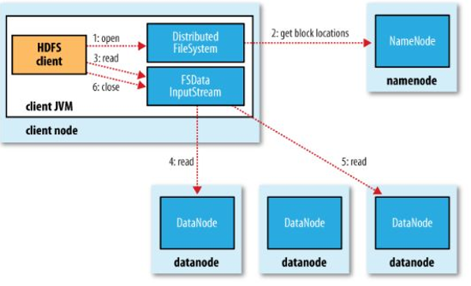

### HDFS write data flow

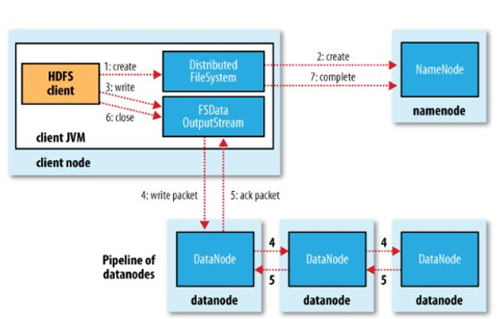

# MapReduce

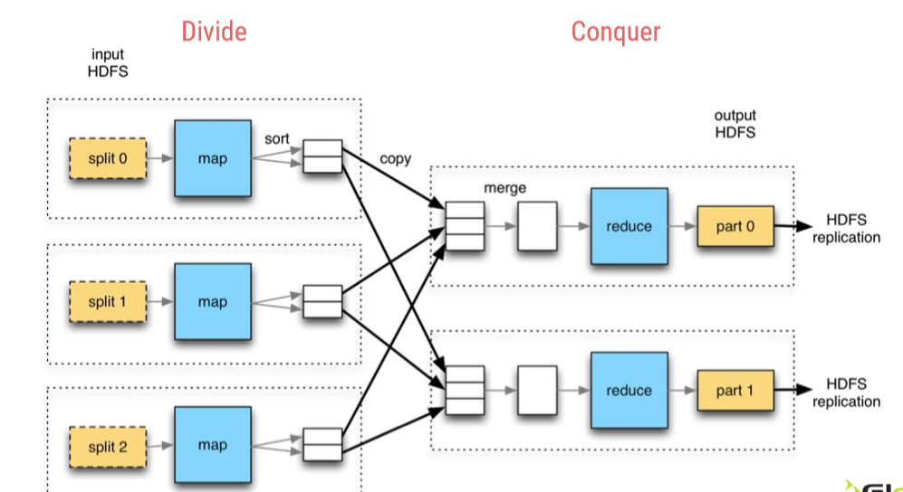

### MapReduce Job

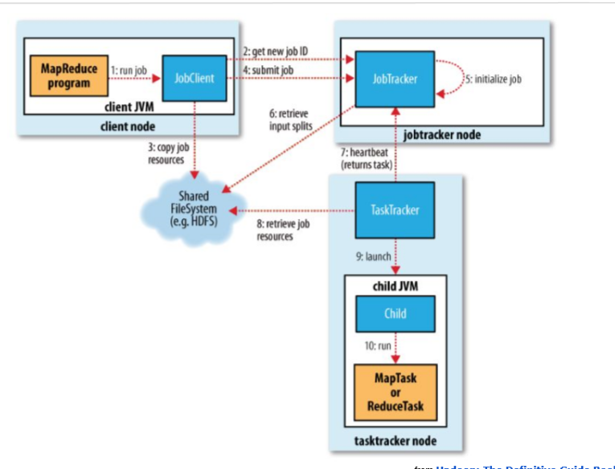

Streaming API

This API allows practically any programming language (we’ll focus on python)

> (Key,Value) pairs fed as a continuous stream of text with sorted keys.

> Data flows into mapper/reducer via *NIX pipes behind the scenes.

○ ideal for prototyping

○ mapper script called one time per split.

○ reducer inputs are (key,value) pairs sorted by key, not (key,list-of-values)

○ reducer script called one time for all full pairs of (key, value)

> the Developer must:

o read data from STDIN (standard input)

o define key,value separator

o split and parse key and value strings to the correct data type

o identify when keys change in the stream

o emit by writing to STDOUT (standard output)

##### Java API

○ requires to know Java, hadoop packages, etc.

○ a bit better performance and more control

○ a bit lengthier to debug.

○ mapper method invoked one time per record.

○ reducer method invoked one time per each pair of (key, list-of-values)

Two Mapreduce Java API versions: Old API (up to 0.20) and New API (after 0.21)

> Two Mapreduce Framework implementations: Mapreduce 1 (Classic) and Mapreduce 2 (YARN) > Both APIs work on both Framework implementations (We’ll focus on NEW API).

> (Key,Value) pairs fed one at a time automatically by framework to mapper/reducer methods.

> The Developer must (minimally):

o write Mapper class with map( ) method

o write Reducer class with reduce( ) method

o write Java Driver class with run( ) method and static main method

> The framework serializes/deserializes built-in data types (using the Writable interface).

# Sqoop

Apache Sqoop(TM) is a tool designed for efficiently transferring bulk data between Apache Hadoop and structured datastores such as relational databases.

Sqoop is a tool designed to transfer data between Hadoop and relational databases. You can use Sqoop to import data from a relational database management system (RDBMS) such as MySQL or Oracle into the Hadoop Distributed File System (HDFS), transform the data in Hadoop MapReduce, and then export the data back into an RDBMS.

Sqoop automates most of this process, relying on the database to describe the schema for the data to be imported. Sqoop uses MapReduce to import and export the data, which provides parallel operation as well as fault tolerance.

With Sqoop, you can import data from a relational database system into HDFS. The input to the import process is a database table. Sqoop will read the table row-by-row into HDFS. The output of this import process is a set of files containing a copy of the imported table. The import process is performed in parallel. For this reason, the output will be in multiple files. These files may be delimited text files (for example, with commas or tabs separating each field), or binary Avro or SequenceFiles containing serialized record data.

The import tool imports an individual table from an RDBMS to HDFS. Each row from a table is represented as a separate record in HDFS. Records can be stored as text files (one record per line), or in binary representation as Avro or SequenceFiles.

A by-product of the import process is a generated Java class which can encapsulate one row of the imported table. This class is used during the import process by Sqoop itself. The Java source code for this class is also provided to you, for use in subsequent MapReduce processing of the data. This class can serialize and deserialize data to and from the SequenceFile format. It can also parse the delimited-text form of a record. These abilities allow you to quickly develop MapReduce applications that use the HDFS-stored records in your processing pipeline. You are also free to parse the delimiteds record data yourself, using any other tools you prefer.

After manipulating the imported records (for example, with MapReduce or Hive) you may have a result data set which you can then export back to the relational database. Sqoop’s export process will read a set of delimited text files from HDFS in parallel, parse them into records, and insert them as new rows in a target database table, for consumption by external applications or users.

Sqoop includes some other commands which allow you to inspect the database you are working with. For example, you can list the available database schemas (with the sqoop-list-databases tool) and tables within a schema (with the sqoop-list-tables tool). Sqoop also includes a primitive SQL execution shell (the sqoop-eval tool).

Most aspects of the import, code generation, and export processes can be customized. You can control the specific row range or columns imported. You can specify particular delimiters and escape characters for the file-based representation of the data, as well as the file format used. You can also control the class or package names used in generated code.

Sqoop’s import tool’s main function is to upload your data into files in HDFS. If you have a Hive metastore associated with your HDFS cluster, Sqoop can also import the data into Hive by generating and executing a CREATE TABLE statement to define the data’s layout in Hive. Importing data into Hive is as simple as adding the **--hive-import** option to your Sqoop command line.

Sqoop supports additional import targets beyond HDFS and Hive. Sqoop can also import records into a table in HBase.

--append: Append data to an existing dataset in HDFS

● --columns <col,col,col…>: Columns to import from table

● --table <table-name>: Table to read

● -e,--query <statement>: Import the results of statement.

● --where <where clause>: WHERE clause to use during import

● -m,--num-mappers <n>: Use n map tasks to import in parallel

Limited to simple queries where there are no ambiguous projections and no OR conditions in the WHERE clause.

sqoop import --connect jdbc:mysql://database.example.com/employees --username aaron -P

$ sqoop import --query 'SELECT a.*, b.* FROM a JOIN b on (a.id == b.id) WHERE $CONDITIONS' -m 1 --target-dir /user/foo/joinresults

● Sqoop natively supports several databases. ● Sqoop can be used with any JDBC-compliant database.

Default: four tasks are used. Some databases may see improved performance by increasing this value to 8 or 16. Do not increase the degree of parallelism higher than that available within your MapReduce cluster. Likewise, do not increase the degree of parallelism higher than that which your database can reasonably support.

Incremental Imports

At the end of an incremental import, the value which should be specified as --last-value for a subsequent import is printed to the screen.

Retrieve only rows newer than some previously-imported set of rows.

● --check-column <col>: Specifies the column to be examined when determining which rows to import.

● --incremental <mode>: Specifies how Sqoop determines which rows are new. Legal values for mode include append and lastmodified.

● --last-value <value>: Specifies the maximum value of the check column from the previous import.

Import all tables

The following conditions must be met:

● Each table must have a single-column primary key. ● You must intend to import all columns of each table. ● You must not intend to use non-default splitting column, nor impose any conditions via a WHERE clause.

$ sqoop import-all-tables --connect jdbc:mysql://db.foo.com/corp Folder found in hdfs: /user/someuser/EMPLOYEES /user/someuser/PAYCHECKS /user/someuser/OFFICE_SUPPLIES

Sqoop’s export process will:

● Read a set of delimited text files from HDFS in parallel. ● Parse them into records. ● Insert them as new rows in a target database table.

The export tool exports a set of files from HDFS back to an RDBMS. The target table must already exist in the database. The input files are read and parsed into a set of records according to the user-specified delimiters.

The default operation is to transform these into a set of INSERT statements that inject the records into the database. In "update mode," Sqoop will generate UPDATE statements that replace existing records in the database, and in "call mode" Sqoop will make a stored procedure call for each record.

--export-dir <dir>: HDFS source path for the export

● --table <table-name>: Table to populate

● --update-mode <mode>: Specify how updates are performed when new rows are found with non-matching keys in database. Legal values for mode include updateonly (default) and allowinsert.

● -m,--num-mappers <n>: Use n map tasks to export in parallel

Export Parallelism: -m,--num-mappers

By default, Sqoop uses four tasks in parallel for the export process. Additional tasks may offer better concurrency. If the database is already bottlenecked on updating indices, invoking triggers, and so on, then additional load may decrease performance.

● Sqoop breaks down export process into multiple transactions

● It is possible that a failed export job may result in partial data being committed to the database. This can further lead to subsequent jobs failing due to insert collisions in some cases, or lead to duplicated data in others.

● Solution: specifying a staging table via the --staging-table option which acts as an auxiliary table that is used to stage exported data. The staged data is finally moved to the destination table in a single transaction.

You must create the staging table prior to running the export job.

● This table must be structurally identical to the target table.

● This table should either be empty before the export job runs, or the --clear-staging-table option must be specified.

● If the staging table contains data and the --clear-staging-table option is specified, Sqoop will delete all of the data before starting the export job.

Not available when export is invoked using the --update-key option for updating existing data, and when stored procedures are used to insert the data.

Insert and Updates

● Default: sqoop-export appends new rows to a table; each input record is transformed into an INSERT statement that adds a row to the target database table. ● If your table has constraints (PK, FK, unique) and already contains data, you must take care to avoid inserting records that violate these constraints. ● The export process will fail if an INSERT statement fails. This mode is primarily intended for exporting records to a new, empty table intended to receive these results.

● If you specify the --update-key argument, Sqoop will instead modify an existing dataset in the database. Each input record is treated as an UPDATE statement that modifies an existing row. ● The row a statement modifies is determined by the column name(s) specified with --update-key.

sqoop export --connect jdbc:mysql://db.example.com/foo --table bar --export-dir /results/bar_data

Sqoop performs a set of INSERT INTO operations, without regard for existing content. If Sqoop attempts to insert rows which violate constraints in the database (for example, a particular primary key value already exists), then the export fails.

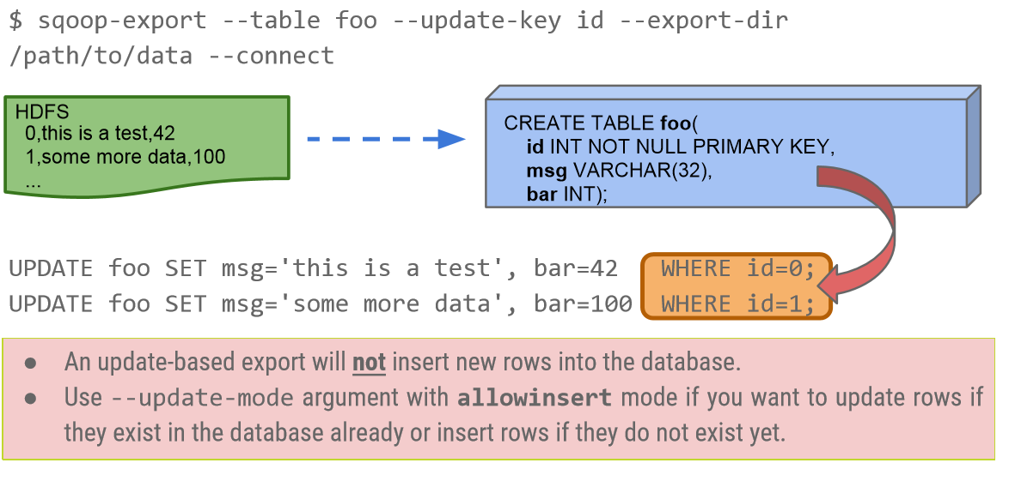

Some commands:

● codegen: Generate code to interact with database records ● create-hive-table: Import a table definition into Hive ● eval: Evaluate a SQL statement and display the results ● export: Export an HDFS directory to a database table ● import: Import a table from a database to HDFS ● import-all-tables: Import tables from a database to HDFS ● list-databases: List available databases on a server ● list-tables: List available tables in a database

Interview Q&A

What is the role of JDBC driver in a Sqoop set up?

To connect to different relational databases sqoop needs a connector. Almost every DB vendor makes this connecter available as a JDBC driver which is specific to that DB. So Sqoop needs the JDBC driver of each of the database it needs to inetract with.

Is JDBC driver enough to connect sqoop to the databases?

No. Sqoop needs both JDBC and connector to connect to a database.

When to use --target-dir and when to use --warehouse-dir while importing data?

To specify a particular directory in HDFS use --target-dir but to specify the parent directory of all the sqoop jobs use --warehouse-dir. In this case under the parent directory sqoop will cerate a directory with the same name as th e table.

How can you import only a subset of rows form a table?

By using the WHERE clause in the sqoop import statement we can import only a subset of rows.

How can we import a subset of rows from a table without using the where clause?

We can run a filtering query on the database and save the result to a temporary table in database.

Then use the sqoop import command without using the --where clause

What is the advantage of using --password-file rather than -P option while preventing the display of password in the sqoop import statement?

The --password-file option can be used inside a sqoop script while the -P option reads from standard input , preventing automation.

What is the default extension of the files produced from a sqoop import using the --compress parameter?

.gz

What is the significance of using --compress-codec parameter?

To get the out file of a sqoop import in formats other than .gz like .bz2 we use the --compress -code parameter.

What is a disadvantage of using --direct parameter for faster data load by sqoop?

The native utilities used by databases to support faster laod do not work for binary data formats like SequenceFile.

How can you control the number of mappers used by the sqoop command?

The Parameter --num-mapers is used to control the number of mappers executed by a sqoop command. We should start with choosing a small number of map tasks and then gradually scale up as choosing high number of mappers initially may slow down the performance on the database side.

How can you avoid importing tables one-by-one when importing a large number of tables from a database?

Using the command

sqoop import-all-tables

--connect

--usrename

--password

--exclude-tables table1,table2 ..

This will import all the tables except the ones mentioned in the exclude-tables clause.

When the source data keeps getting updated frequently, what is the approach to keep it in sync with the data in HDFS imported by sqoop?

sqoop can have 2 approaches.

**a** − To use the --incremental parameter with append option where value of some columns are checked and only in case of modified values the row is imported as a new row.

**b** − To use the --incremental parameter with lastmodified option where a date column in the source is checked for records which have been updated after the last import.

What is the usefulness of the options file in sqoop.

The options file is used in sqoop to specify the command line values in a file and use it in the sqoop commands.

For example the --connect parameter's value and --user name value scan be stored in a file and used again and again with different sqoop commands.

Is it possible to add a parameter while running a saved job?

Yes, we can add an argument to a saved job at runtime by using the --exec option

sqoop job --exec jobname -- -- newparameter

How do you fetch data which is the result of join between two tables?

By using the --query parameter in place of --table parameter we can specify a sql query. The result of the query will be imported.

How can we slice the data to be imported to multiple parallel tasks?

Using the --split-by parameter we specify the column name based on which sqoop will divide the data to be imported into multiple chunks to be run in parallel.

How can you choose a name for the mapreduce job which is created on submitting a free-form query import?

By using the --mapreduce-job-name parameter. Below is a example of the command.

sqoop import \

--connect jdbc:mysql://mysql.example.com/sqoop \

--username sqoop \

--password sqoop \

--query 'SELECT normcities.id, \

countries.country, \

normcities.city \

FROM normcities \

JOIN countries USING(country_id) \

WHERE $CONDITIONS' \

--split-by id \

--target-dir cities \

--mapreduce-job-name normcities

Before starting the data transfer using mapreduce job, sqoop takes a long time to retrieve the minimum and maximum values of columns mentioned in –split-by parameter. How can we make it efficient?

We can use the --boundary –query parameter in which we specify the min and max value for the column based on which the split can happen into multiple mapreduce tasks. This makes it faster as the query inside the –boundary-query parameter is executed first and the job is ready with the information on how many mapreduce tasks to create before executing the main query.

What is the difference between the parameters sqoop.export.records.per.statement and sqoop.export.statements.per.transaction

The parameter “sqoop.export.records.per.statement” specifies the number of records that will be used in each insert statement.

But the parameter “sqoop.export.statements.per.transaction” specifies how many insert statements can be processed parallel during a transaction.

How will you implement all-or-nothing load using sqoop?

Using the staging-table option we first load the data into a staging table and then load it to the final target table only if the staging load is successful.

How do you clear the data in a staging table before loading it by Sqoop?

By specifying the –clear-staging-table option we can clear the staging table before it is loaded. This can be done again and again till we get proper data in staging.

How will you update the rows that are already exported?

The parameter --update-key can be used to update existing rows. In it a comma-separated list of columns is used which uniquely identifies a row. All of these columns is used in the WHERE clause of the generated UPDATE query. All other table columns will be used in the SET part of the query.

How can you sync a exported table with HDFS data in which some rows are deleted?

Truncate the target table and load it again.

How can you export only a subset of columns to a relational table using sqoop?

By using the –column parameter in which we mention the required column names as a comma separated list of values.

How can we load to a column in a relational table which is not null but the incoming value from HDFS has a null value?

By using the –input-null-string parameter we can specify a default value and that will allow the row to be inserted into the target table.

How can you schedule a sqoop job using Oozie?

Oozie has in-built sqoop actions inside which we can mention the sqoop commands to be executed.

Sqoop imported a table successfully to HBase but it is found that the number of rows is fewer than expected. What can be the cause?

Some of the imported records might have null values in all the columns. As Hbase does not allow all null values in a row, those rows get dropped.

Give a sqoop command to show all the databases in a MySql server.

$ sqoop list-databases --connect jdbc:mysql://database.example.com/

What do you mean by Free Form Import in Sqoop?

Sqoop can import data form a relational database using any SQL query rather than only using table and column name parameters.

How can you force sqoop to execute a free form Sql query only once and import the rows serially.

By using the –m 1 clause in the import command, sqoop cerates only one mapreduce task which will import the rows sequentially.

In a sqoop import command you have mentioned to run 8 parallel Mapreduce task but sqoop runs only 4. What can be the reason?

The Mapreduce cluster is configured to run 4 parallel tasks. So the sqoop command must have number of parallel tasks less or equal to that of the MapReduce cluster.

What is the importance of --split-by clause in running parallel import tasks in sqoop?

The –split-by clause mentions the column name based on whose value the data will be divided into groups of records. These group of records will be read in parallel by the mapreduce tasks.

What does this sqoop command achieve?

$ sqoop import --connnect <connect-str> --table foo --target-dir /dest \

It imports data from a database to a HDFS file named foo located in the directory /dest

What happens when a table is imported into a HDFS directory which already exists using the –apend parameter?

Using the --append argument, Sqoop will import data to a temporary directory and then rename the files into the normal target directory in a manner that does not conflict with existing filenames in that directory.

How can you control the mapping between SQL data types and Java types?

By using the --map-column-java property we can configure the mapping between.

Below is an example

$ sqoop import ... --map-column-java id = String, value = Integer

How to import only the updated rows form a table into HDFS using sqoop assuming the source has last update timestamp details for each row?

By using the lastmodified mode. Rows where the check column holds a timestamp more recent than the timestamp specified with --last-value are imported.

What are the two file formats supported by sqoop for import?

Delimited text and Sequence Files.

Give a sqoop command to import the columns employee_id,first_name,last_name from the MySql table Employee

$ sqoop import --connect jdbc:mysql://host/dbname --table EMPLOYEES \

--columns "employee_id,first_name,last_name"

Give a sqoop command to run only 8 mapreduce tasks in parallel

$ sqoop import --connect jdbc:mysql://host/dbname --table table_name\

-m 8

What does the following query do?

$ sqoop import --connect jdbc:mysql://host/dbname --table EMPLOYEES \

--where "start_date > '2012-11-09'

It imports the employees who have joined after 9-NOv-2012.

Give a Sqoop command to import all the records from employee table divided into groups of records by the values in the column department_id.

$ sqoop import --connect jdbc:mysql://db.foo.com/corp --table EMPLOYEES \

--split-by dept_id

What does the following query do?

$ sqoop import --connect jdbc:mysql://db.foo.com/somedb --table sometable \

--where "id > 1000" --target-dir /incremental_dataset --append

It performs an incremental import of new data, after having already imported the first 100,0rows of a table

Give a sqoop command to import data from all tables in the MySql DB DB1.

sqoop import-all-tables --connect jdbc:mysql://host/DB1

Give a command to execute a stored procedure named proc1 which exports data to from MySQL db named DB1 into a HDFS directory named Dir1.

$ sqoop export --connect jdbc:mysql://host/DB1 --call proc1 \

--export-dir /Dir1

What is a sqoop metastore?

It is a tool using which Sqoop hosts a shared metadata repository. Multiple users and/or remote users can define and execute saved jobs createdwithsqoopjobcreatedwithsqoopjob defined in this metastore.

Clients must be configured to connect to the metastore in sqoop-site.xml or with the --meta-connect argument.

What is the purpose of sqoop-merge?

The merge tool combines two datasets where entries in one dataset should overwrite entries of an older dataset preserving only the newest version of the records between both the data sets.

How can you see the list of stored jobs in sqoop metastore?

sqoop job –list

Give the sqoop command to see the content of the job named myjob?

Sqoop job –show myjob

Which database the sqoop metastore runs on?

Running sqoop-metastore launches a shared HSQLDB database instance on the current machine.

Where can the metastore database be hosted?

The metastore database can be hosted anywhere within or outside of the Hadoop cluster..

# Pig

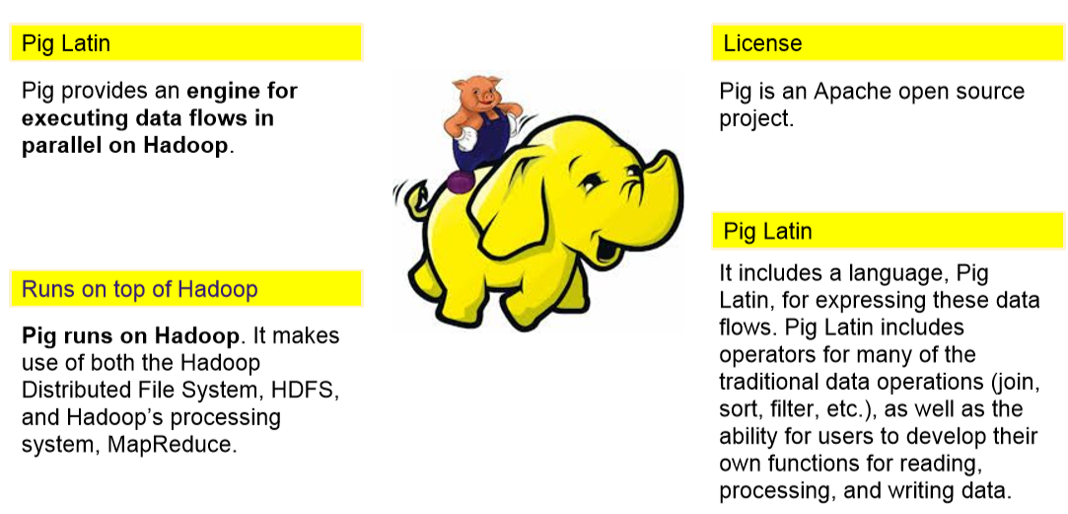

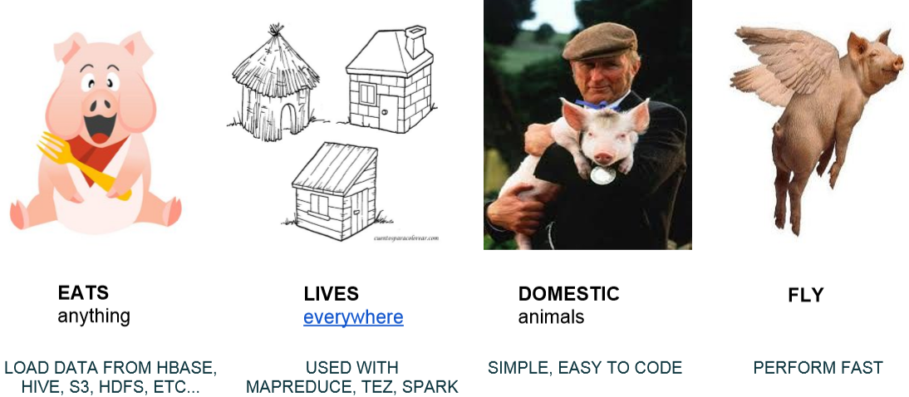

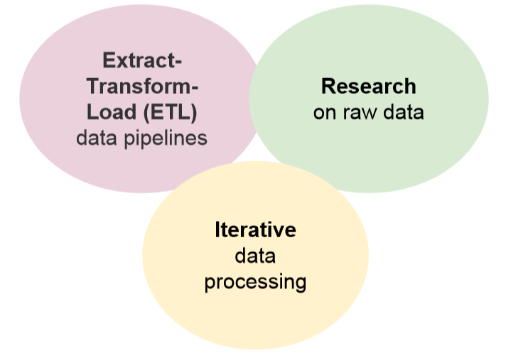

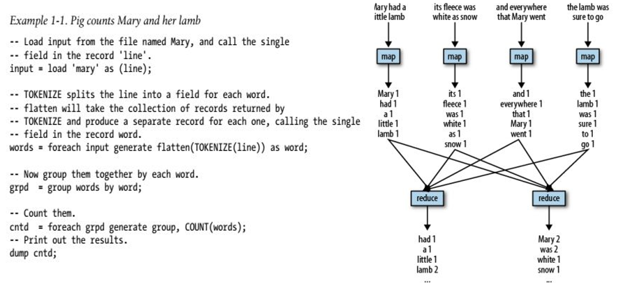

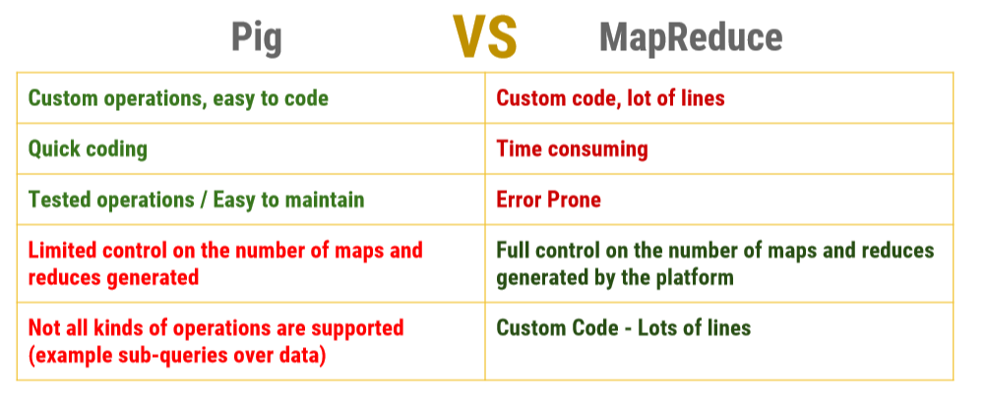

TYPE DESCRIPTION

map A map in Pig is a chararray to data element mapping, where that element can be any. Pig type, including a complex type. The chararray is called a key and is used as an index to find the element, referred to as the value. ['name'#'bob', 'age'#55]

tuple A tuple is a fixed-length, ordered collection of Pig data elements. Tuples are divided into fields, with each field containing one data element. These elements can be of any type—they do not all need to be the same type.

bag A bag is an unordered collection of tuples. Because it has no order, it is not possible to reference tuples in a bag by position. Like tuples, a bag can, but is not required to, have a schema associated with it.

Pig Latin - Schemas

X = FOREACH C GENERATE FLATTEN(B) AS (f1:int, f2:int, f3:int), group;

A = LOAD 'data' AS (f1:int, f2:int);

A = LOAD 'data' AS (T: tuple (f1:int, f2:int, f3:int));

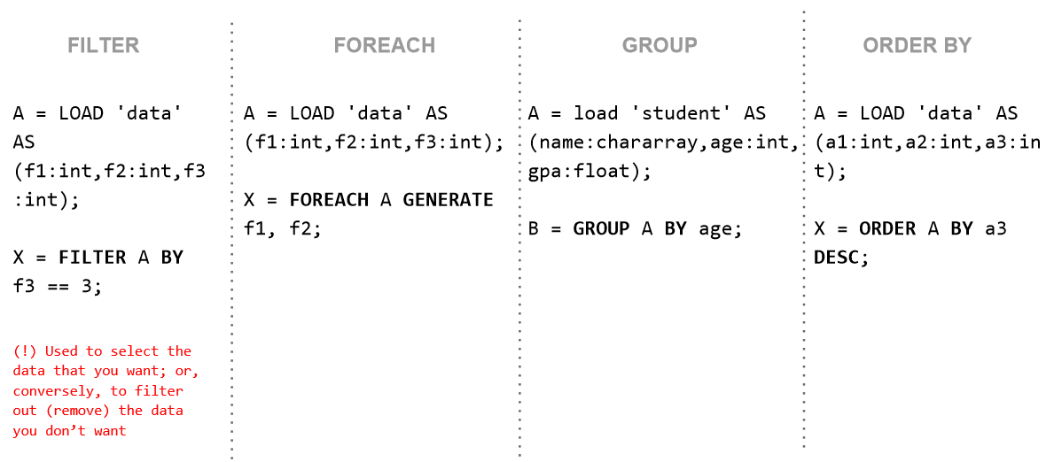

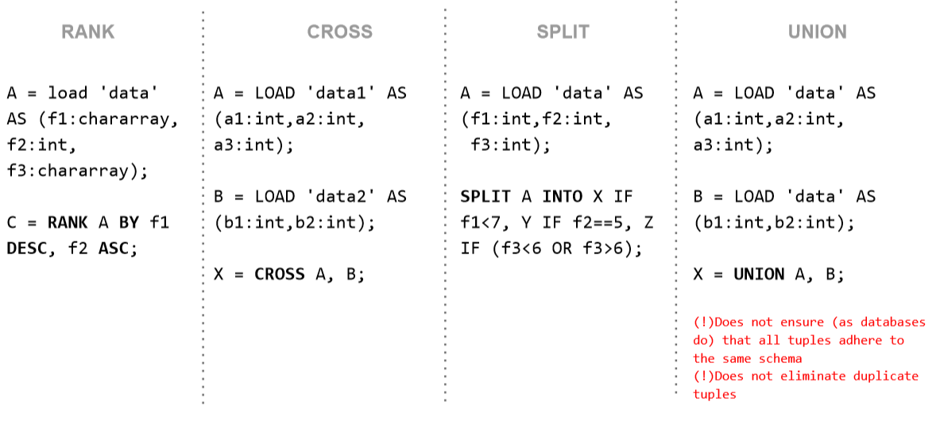

Types of Joins

Inner Join - Outer Join

Join Implementations

Replicated – Skewed – Merge - Merge-Sparse

daily = load 'NYSE_daily' as (exchange:chararray, symbol:chararray,date:chararray, open:float, high:float, low:float, close:float, volume:int, adj_close:float);

divs = load 'NYSE_dividends' as (exchange:chararray, symbol:chararray, date:chararray, dividends:float);

jnd = join daily by (exchange, symbol), divs by (exchange, symbol) using 'replicated';

Apache DataFu Pig is a collection of user-defined functions for working with large scale data in Apache Pig. It has a number of useful functions available

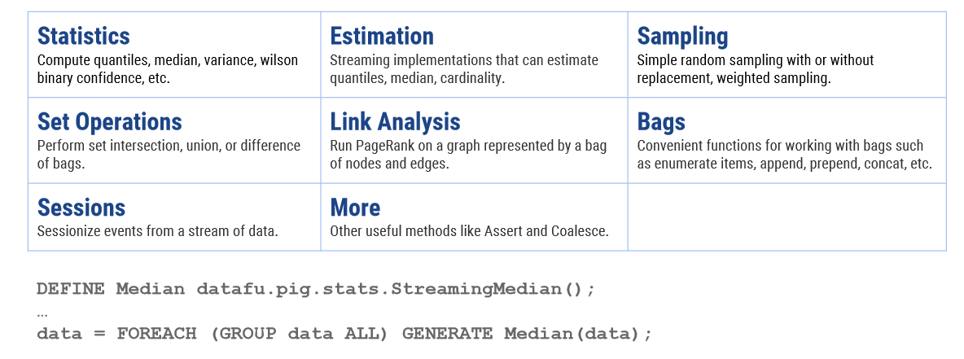

Performance Considerations and Tips

✓ Pre--process data

✓ Extract only the fields that you will need. “Project Early And Often”

✓ Filter first. “Filter Early and Often”

✓ Drop Nulls Before a Join

✓ Avoid Joins

✓ Choose the appropriate join command “Take advantage of Join Operations”

✓ Set Level of parallelism

✓ Check Mapper-Reducer Statistics from Console

✓ Understand what kind of mapper-reducers are being runned behind. Use EXPLAIN for this purpose

✓ Prefer DISTINCT over GROUP BY/GENERATE

✓ Compress the results of intermediate Jobs

✓ Combine Small Input Files

Arch

Workflow

datamodel

# Hive

➢ Structured Data Warehouse over Hadoop ➢ SQL -> Map Reduce ➢ HDFS Storage ➢ Metadata in RDBMS ➢ Aggregation functions

Hive is not designed for online transaction processing (OLTP) workloads. It is best used for traditional data warehousing tasks.

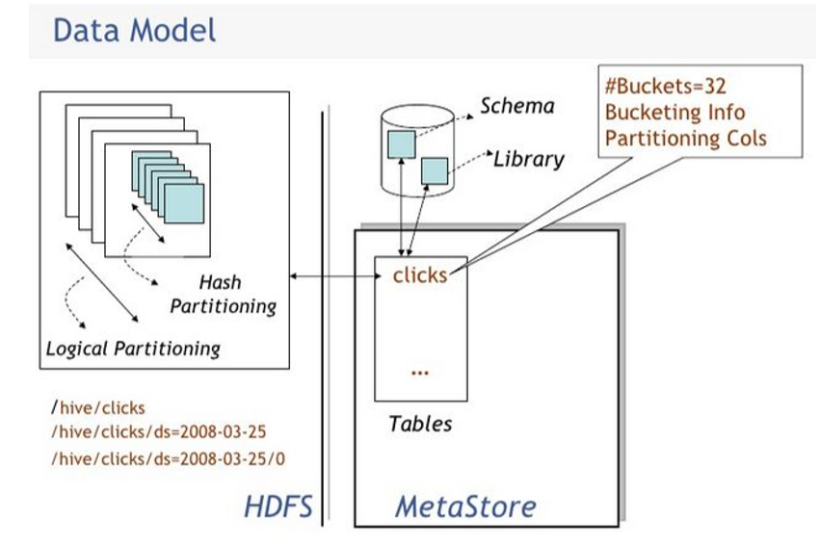

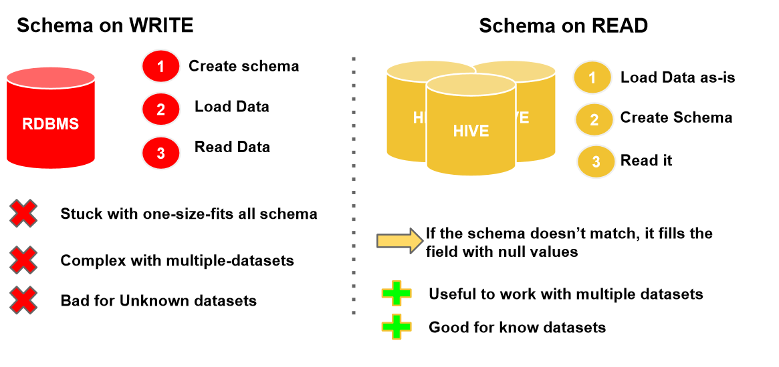

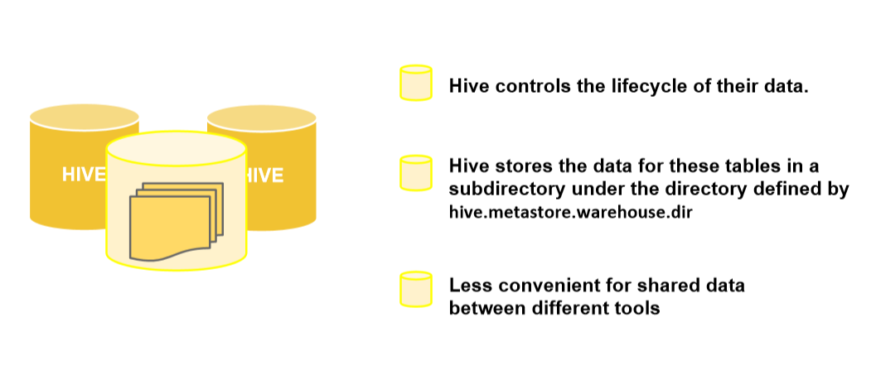

When we DROP an internal table Hive deletes the data inside the table

External tables:

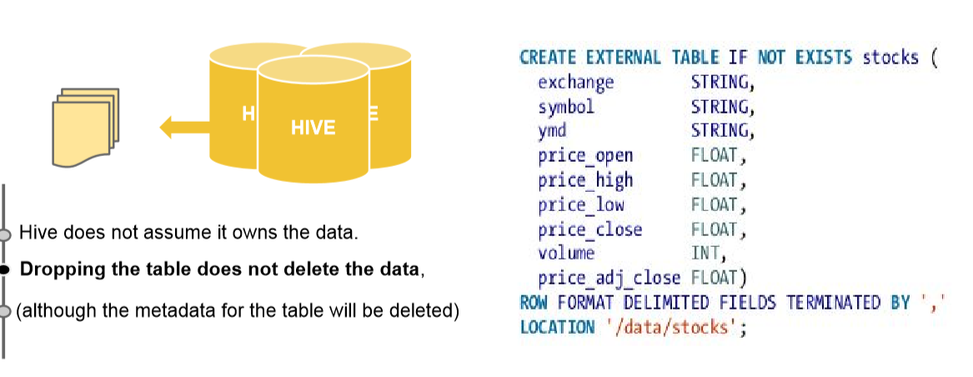

Partitioned Tables:

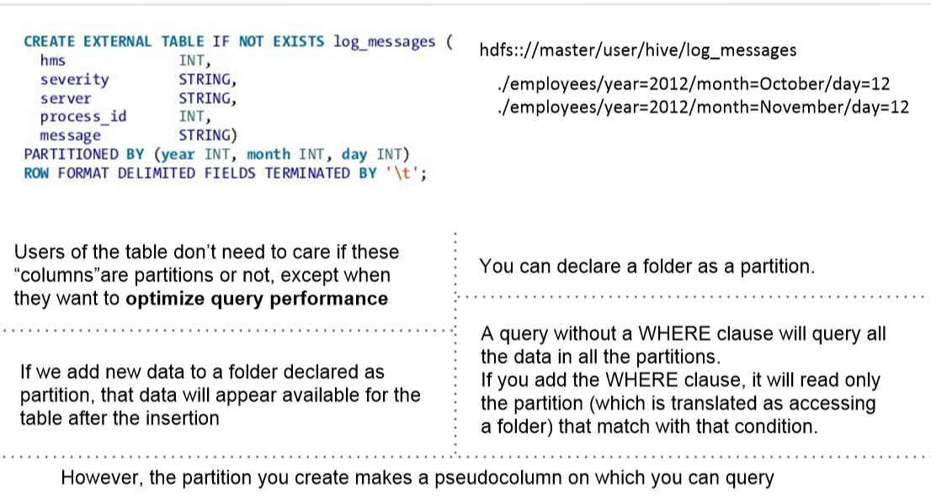

Bucketed Tables:

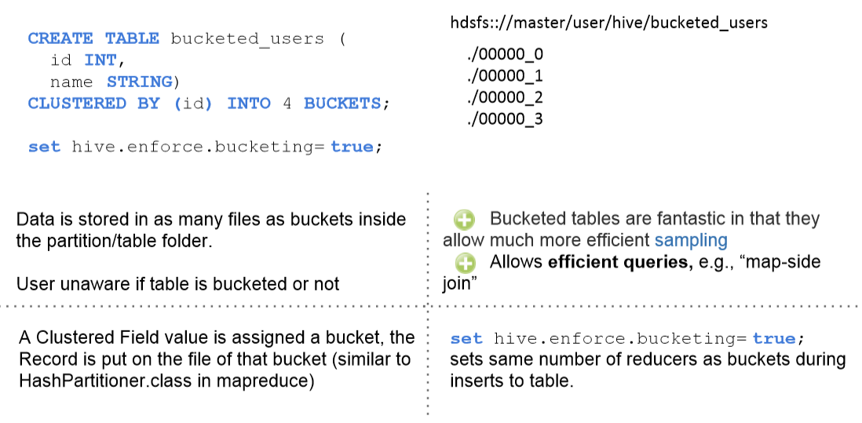

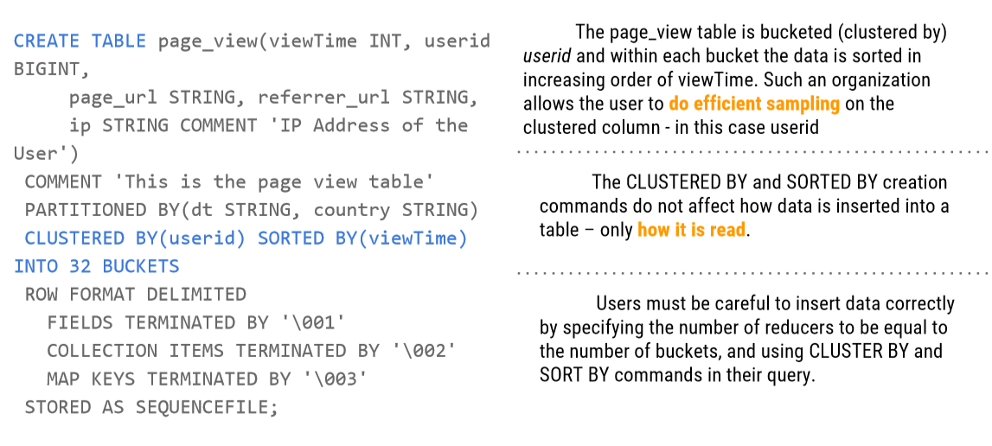

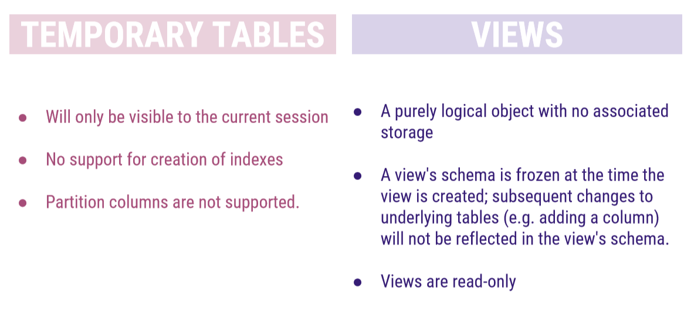

Reading files...Row way

CREATE TABLE usuarios( nombre STRING, edad INT) ROW FORMAT DELIMITED FIELDS TERMINATED BY '\t' LINES TERMINATED BY '\n';

Reading file...SerDe way

➢ HDFS Files → InputFileFormat → <key, value> → Deserializer → Row object

○ Example: Query data

➢ Row object → Serializer → <key, value> → OutputFileFormat → HDFS Files

○ Insert

CREATE EXTERNAL TABLE tweets ( ... retweeted_status STRUCT<text:STRING, user:STRUCT<screen_name:STRING, name:STRING> >, text STRING, ... ) ROW FORMAT SERDE 'com.cloudera.hive.serde.JSONSerDe'

Using Json SerDe you can save storage

If your schema has a lot of columns and often they are null. It’s a good idea to use SerDe. You can create json without the keys (columns) and Serde will show it as null.

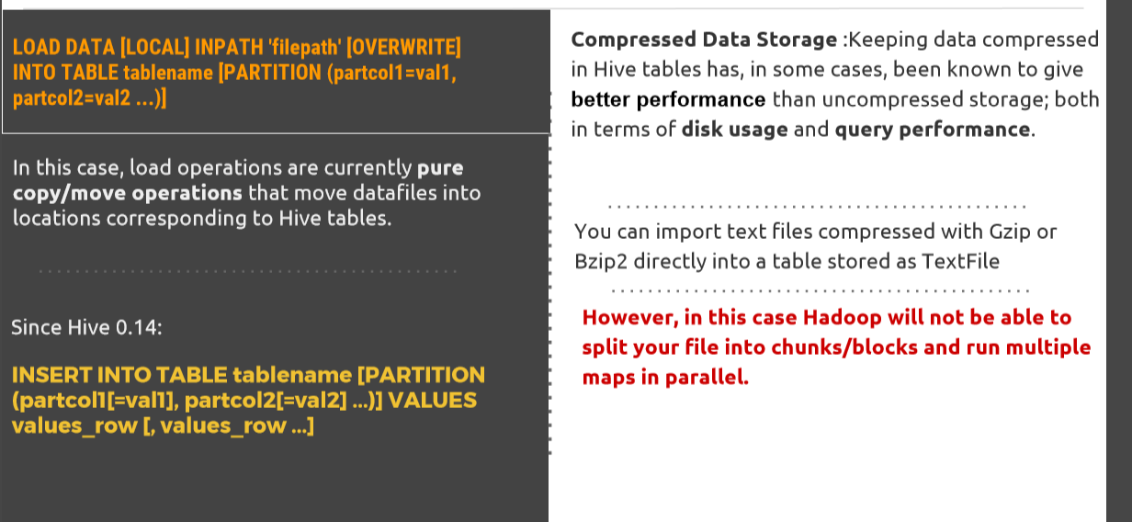

Loading Data into a table with another format

CREATE TABLE raw (line STRING) ROW FORMAT DELIMITED FIELDS TERMINATED BY '\t' LINES TERMINATED BY '\n';

CREATE TABLE raw_sequence (line STRING) STORED AS SEQUENCEFILE;

LOAD DATA LOCAL INPATH '/tmp/weblogs/20090603-access.log.gz' INTO TABLE raw;

SET hive.exec.compress.output=true; SET io.seqfile.compression.type=BLOCK; -- NONE/RECORD/BLOCK (see below) INSERT OVERWRITE TABLE raw_sequence SELECT * FROM raw;

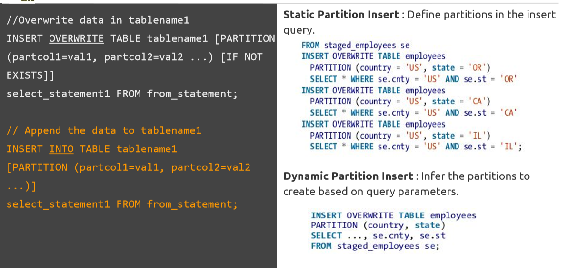

Inserting Data into a table - Create Table as Select (CTAS)

The table created by CTAS is atomic, meaning that the table is not seen by other users until all the query results are populated.

CTAS has these restrictions: - The target table cannot be a partitioned table. - The target table cannot be an external table. - The target table cannot be a list bucketing table.

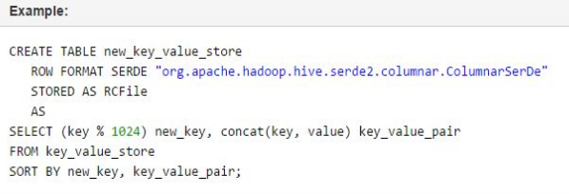

Queries:

> SELECT [ALL | DISTINCT] select_expr, select_expr, ... FROM table_reference [WHERE where_condition] [GROUP BY col_list] [CLUSTER BY col_list | [DISTRIBUTE BY col_list] [SORT BY col_list]] [LIMIT number];

> SELECT * FROM log_messages WHERE year = 2014 AND month = ‘December’;

Joins:

> SELECT a.* FROM a JOIN b ON (a.id = b.id AND a.department = b.department);

> NOT ALLOWED(NON-Equality): SELECT a.* FROM a JOIN b ON (a.id <> b.id);

# Hive converts joins over multiple tables into a single map/reduce job if for every table the same column is used in the join clause. if not, it is converted into multiple map/reduce jobs > SELECT a.val, b.val, c.val FROM a JOIN b ON (a.key = b.key1) JOIN c ON (c.key = b.key1) #1 M-R

#OUTER JOINS: Outer join allow you to find nonmatches in the tables being joined. > SELECT sales.* FROM sales RIGHT OUTER JOIN employee ON sales.employeeid = employee.id

#SEMI JOINS > SELECT * FROM singers WHERE singers.id IN (SELECT sales.singerId from sales)

#MAP JOINS: If one table fits in memory, Hive can load it into memory in the map phase. It does not need a reducer. > SELECT /*+ MAPJOIN(b) */ a.key, a.value FROM a JOIN b ON a.key = b.key; > SELECT /*+ MAPJOIN(c) */ * FROM orders o JOIN cities c ON (o.city_id = c.id);

(!) Bucketing: Map joins can take advantage of bucketed tables, since a mapper working on a bucket of the left table needs to load only the corresponding buckets of the right table to perform the join. The syntax for the join is the same as for the inmemory case shown earlier; however, you also need to enable the optimization with the following: SET hive.optimize.bucketmapjoin=true;

#Hive has limited support for subqueries, permitting a subquery in the FROM clause, in a WHERE clause or inside an IN or EXISTS statement.

SELECT t3.col FROM ( SELECT a+b AS col FROM t1 UNION ALL SELECT c+d AS col FROM t2 ) t3

SELECT A FROM T1 WHERE EXISTS ( SELECT B FROM T2 WHERE T1.X = T2.Y)

SELECT * FROM A WHERE A.a IN (SELECT foo FROM B);

# ORDER BY: it performs a total Ordering of the query result set. This means that all the data is passed through a single reducer. May take long time to execute. > SELECT s.year, s.id, s.price FROM stock s ORDER BY s.year ASC, s.price DESC

# SORT BY: it performs a local Ordering of the query result set. This means that all the data is passed through a single reducer. May take long time to execute. > SELECT s.year, s.id, s.price FROM stock s SORT BY s.year ASC, s.price DESC

# DISTRIBUTED BY WITH SORT BY: controls how map output is divided among reducers. # We can use DISTRIBUTE BY to ensure that the records for each stock symbol go to the same reducer, then use SORT BY to order the data the way we want. > SELECT s.ymd, s.symbol, s.price_close > FROM stocks s > DISTRIBUTE BY s.symbol > SORT BY s.symbol ASC, s.ymd ASC;

INDEXES

CREATE INDEX index_name ON TABLE base_table_name (col_name, ...) AS 'index.handler.class.name' [WITH DEFERRED REBUILD] [IDXPROPERTIES (property_name=property_value, ...)] [IN TABLE index_table_name] [PARTITIONED BY (col_name, ...)] [ [ ROW FORMAT ...] STORED AS ... | STORED BY ... ] [LOCATION hdfs_path] [TBLPROPERTIES (...)] [COMMENT "index comment"]

❏ Improve the speed of query lookup on certain columns of a table ❏ Additional processing to create the index and disk space to store the index ❏ Only single-table indexes are supported. ❏ By default, index partitioning matches the partitioning of the base table.For example, a table may be partitioned by date+region even though the index is partitioned by date alone

Compression ↑Save disk storage. Reduce traffic in I/O. ↓CPU Overhead.

Trade-Off between Compression Codes: -> Speed to de/compress -> Space on Disk (!) Important: Splittable

Compression Codecs ● LZO ● Snappy ● Bzip2 (!) ● LZO(!)

File Formats: ❏ Default: Text format ❏ Sequence Files ❏ RCFile

Functions

➢ Standard Functions (UDF, or just DF) ➢ Table Generating Function (UDTF) ➢ Aggregation Function (UDAF)

➢ Macros hive> CREATE TEMPORARY MACRO SIGMOID (x DOUBLE) 1.0 / (1.0 + EXP(-x)); hive> SELECT SIGMOID(2) FROM src LIMIT 1;

Meta commandos

> show functions;

> describe function [function name]

> describe function extended [function name]

Presto is a distributed SQL query engine optimized for ad-hoc analysis at interactive speed. It supports standard ANSI SQL, including complex queries, aggregations, joins, and window functions.

The execution model of Presto is fundamentally different from Hive/MapReduce. Hive translates queries into multiple stages of MapReduce tasks that execute one after another. Each task reads inputs from disk and writes intermediate output back to disk. In contrast, the Presto engine does not use MapReduce. It employs a custom query and execution engine with operators designed to support SQL semantics. In addition to improved scheduling, all processing is in memory and pipelined across the network between stages. This avoids unnecessary I/O and associated latency overhead. The pipelined execution model runs multiple stages at once, and streams data from one stage to the next as it becomes available. This significantly reduces end-to-end latency for many types of queries.

Good Practices

* Partitions
* Large files rather than smaller ones
* De-normalization
* Strict Mode
* Compression
* Use indexes
* Parallelization
* Reuse JVM
* Optimize Joins
* Be carefull with the sintax in your queries.
* Tune number of reducers

# Spark

Spark was introduced by Apache Software Foundation for speeding up the Hadoop computational computing software process.

As against a common belief, **Spark is not a modified version of Hadoop**and is not, really, dependent on Hadoop because it has its own cluster management. Hadoop is just one of the ways to implement Spark.

Spark uses Hadoop in two ways – one is **storage** and second is **processing**. Since Spark has its own cluster management computation, it uses Hadoop for storage purpose only.

Apache Spark

Apache Spark is a lightning-fast cluster computing technology, designed for fast computation. It is based on Hadoop MapReduce and it extends the MapReduce model to efficiently use it for more types of computations, which includes interactive queries and stream processing. The main feature of Spark is its **in-memory cluster computing** that increases the processing speed of an application.

Spark is designed to cover a wide range of workloads such as batch applications, iterative algorithms, interactive queries and streaming. Apart from supporting all these workload in a respective system, it reduces the management burden of maintaining separate tools.

Evolution of Apache Spark

Spark is one of Hadoop’s sub project developed in 2009 in UC Berkeley’s AMPLab by Matei Zaharia. It was Open Sourced in 2010 under a BSD license. It was donated to Apache software foundation in 2013, and now Apache Spark has become a top level Apache project from Feb-2014.

### Features of Apache Spark

Apache Spark has following features.

* **Speed** − Spark helps to run an application in Hadoop cluster, up to 100 times faster in memory, and 10 times faster when running on disk. This is possible by reducing number of read/write operations to disk. It stores the intermediate processing data in memory.
* **Supports multiple languages** − Spark provides built-in APIs in Java, Scala, or Python. Therefore, you can write applications in different languages. Spark comes up with 80 high-level operators for interactive querying.
* **Advanced Analytics** − Spark not only supports ‘Map’ and ‘reduce’. It also supports SQL queries, Streaming data, Machine learning (ML), and Graph algorithms.

### Spark Built on Hadoop

The following diagram shows three ways of how Spark can be built with Hadoop components.

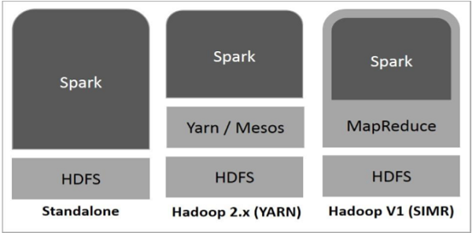

There are three ways of Spark deployment as explained below.

* **Standalone** − Spark Standalone deployment means Spark occupies the place on top of HDFS(Hadoop Distributed File System) and space is allocated for HDFS, explicitly. Here, Spark and MapReduce will run side by side to cover all spark jobs on cluster.
* **Hadoop Yarn** − Hadoop Yarn deployment means, simply, spark runs on Yarn without any pre-installation or root access required. It helps to integrate Spark into Hadoop ecosystem or Hadoop stack. It allows other components to run on top of stack.
* **Spark in MapReduce (SIMR)** − Spark in MapReduce is used to launch spark job in addition to standalone deployment. With SIMR, user can start Spark and uses its shell without any administrative access.

### Components of Spark

The following illustration depicts the different components of Spark.

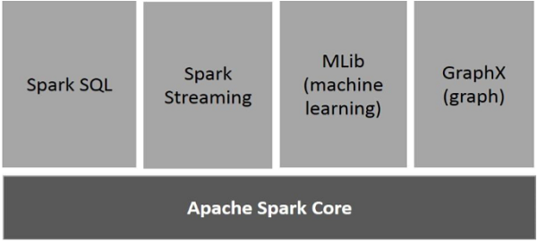

Apache Spark Core

Spark Core is the underlying general execution engine for spark platform that all other functionality is built upon. It provides In-Memory computing and referencing datasets in external storage systems.

Spark SQL

Spark SQL is a component on top of Spark Core that introduces a new data abstraction called SchemaRDD, which provides support for structured and semi-structured data.

Spark Streaming

Spark Streaming leverages Spark Core's fast scheduling capability to perform streaming analytics. It ingests data in mini-batches and performs RDD (Resilient Distributed Datasets) transformations on those mini-batches of data.

MLlib (Machine Learning Library)

MLlib is a distributed machine learning framework above Spark because of the distributed memory-based Spark architecture. It is, according to benchmarks, done by the MLlib developers against the Alternating Least Squares (ALS) implementations. Spark MLlib is nine times as fast as the Hadoop disk-based version of **Apache Mahout** (before Mahout gained a Spark interface).

GraphX

GraphX is a distributed graph-processing framework on top of Spark. It provides an API for expressing graph computation that can model the user-defined graphs by using Pregel abstraction API. It also provides an optimized runtime for this abstraction.

## Resilient Distributed Datasets

Resilient Distributed Datasets (RDD) is a fundamental data structure of Spark. It is an immutable distributed collection of objects. Each dataset in RDD is divided into logical partitions, which may be computed on different nodes of the cluster. RDDs can contain any type of Python, Java, or Scala objects, including user-defined classes.

Formally, an RDD is a read-only, partitioned collection of records. RDDs can be created through deterministic operations on either data on stable storage or other RDDs. RDD is a fault-tolerant collection of elements that can be operated on in parallel.

There are two ways to create RDDs − **parallelizing** an existing collection in your driver program, or **referencing a dataset** in an external storage system, such as a shared file system, HDFS, HBase, or any data source offering a Hadoop Input Format.

Spark makes use of the concept of RDD to achieve faster and efficient MapReduce operations. Let us first discuss how MapReduce operations take place and why they are not so efficient.

### Data Sharing is Slow in MapReduce

MapReduce is widely adopted for processing and generating large datasets with a parallel, distributed algorithm on a cluster. It allows users to write parallel computations, using a set of high-level operators, without having to worry about work distribution and fault tolerance.

Unfortunately, in most current frameworks, the only way to reuse data between computations (Ex − between two MapReduce jobs) is to write it to an external stable storage system (Ex − HDFS). Although this framework provides numerous abstractions for accessing a cluster’s computational resources, users still want more.

Both **Iterative** and **Interactive** applications require faster data sharing across parallel jobs. Data sharing is slow in MapReduce due to **replication, serialization**, and **disk IO**. Regarding storage system, most of the Hadoop applications, they spend more than 90% of the time doing HDFS read-write operations.

### Iterative Operations on MapReduce

Reuse intermediate results across multiple computations in multi-stage applications. The following illustration explains how the current framework works, while doing the iterative operations on MapReduce. This incurs substantial overheads due to data replication, disk I/O, and serialization, which makes the system slow.

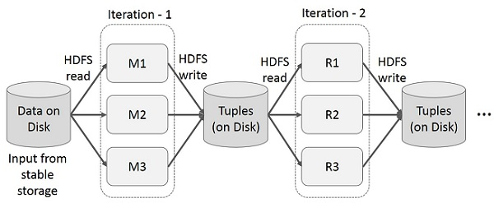

Interactive Operations on MapReduce

User runs ad-hoc queries on the same subset of data. Each query will do the disk I/O on the stable storage, which can dominates application execution time.

The following illustration explains how the current framework works while doing the interactive queries on MapReduce.

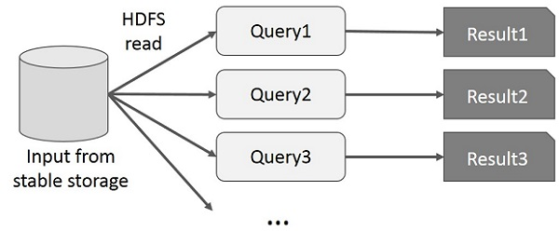

### Data Sharing using Spark RDD

Data sharing is slow in MapReduce due to **replication, serialization**, and **disk IO**. Most of the Hadoop applications, they spend more than 90% of the time doing HDFS read-write operations.

Recognizing this problem, researchers developed a specialized framework called Apache Spark. The key idea of spark is **R**esilient **D**istributed **D**atasets (RDD); it supports in-memory processing computation. This means, it stores the state of memory as an object across the jobs and the object is sharable between those jobs. Data sharing in memory is 10 to 100 times faster than network and Disk.

Let us now try to find out how iterative and interactive operations take place in Spark RDD.

### Iterative Operations on Spark RDD

The illustration given below shows the iterative operations on Spark RDD. It will store intermediate results in a distributed memory instead of Stable storage (Disk) and make the system faster.

**Note** − If the Distributed memory (RAM) is not sufficient to store intermediate results (State of the JOB), then it will store those results on the disk.

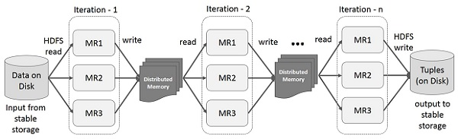

Interactive Operations on Spark RDD

This illustration shows interactive operations on Spark RDD. If different queries are run on the same set of data repeatedly, this particular data can be kept in memory for better execution times.

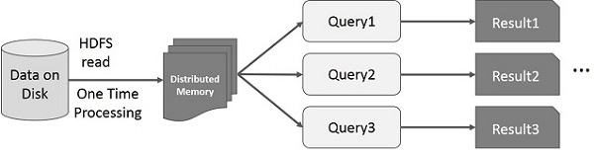

By default, each transformed RDD may be recomputed each time you run an action on it. However, you may also **persist** an RDD in memory, in which case Spark will keep the elements around on the cluster for much faster access, the next time you query it. There is also support for persisting RDDs on disk, or replicated across multiple nodes.

## Apache open source Hadoop ecosystem elements

The Apache Hadoop project actively supports multiple projects intended to extend Hadoop’s capabilities and make it easier to use. There are several top-level projects to create development tools as well as for managing Hadoop data flow and processing. Many commercial third-party solutions build on the technologies developed within the Apache Hadoop ecosystem.

Spark, Pig, and Hive are three of the best-known Apache Hadoop projects. Each is used to create applications to process Hadoop data. While there are a lot of articles and discussions about whether Spark, Hive or Pig is better, in practice many organizations do not only use a single one because each is optimized for specific functions.

#### [Spark](http://www.bmc.com/guides/hadoop-apache-spark.html)

Spark is both a programming model and a computing model. It provides a gateway to in-memory computing for Hadoop, which is a big reason for its popularity and wide adoption. Spark provides an alternative to MapReduce that enables workloads to execute in memory, instead of on disk. Spark accesses data from HDFS but bypasses the MapReduce processing framework, and thus eliminates the resource-intensive disk operations that MapReduce requires. By using in-memory computing, Spark workloads typically run between 10 and 100 times faster compared to disk execution.

Spark can be used independently of Hadoop. However, it is used most commonly with Hadoop as an alternative to MapReduce for data processing. Spark can easily coexist with MapReduce and with other ecosystem components that perform other tasks.

Spark is also popular because it supports SQL, which helps overcome a shortcoming in core Hadoop technology. The Spark programming environment works interactively with Scala, Python, and R shells. It has been used for data extract/transform/load (ETL) operations, stream processing, machine learning development and with the Apache GraphX API for graph computation and display. Spark can run on a variety of Hadoop and non-Hadoop clusters, including Amazon S3.

#### Hive

Hive is data warehousing software that addresses how data is structured and queried in distributed Hadoop clusters. Hive is also a popular development environment that is used to write queries for data in the Hadoop environment. It provides tools for ETL operations and brings some SQL-like capabilities to the environment. Hive is a declarative language that is used to develop applications for the Hadoop environment, however it does not support real-time queries.

Hive has several components, including:

* **HCatalog**– Helps data processing tools read and write data on the grid. It supports MapReduce and Pig.
* **WebHCat**– Lets you use an HTTP/REST interface to run MapReduce, Yarn, Pig, and Hive jobs.
* **HiveQL**– Hive’s query language intended as a way for SQL developers to easily work in Hadoop. It is similar to SQL and helps both structure and query data in distributed Hadoop clusters.

Hive queries can run from the Hive shell, JDBC, or ODBC. MapReduce (or an alternative) breaks down HiveQL statements for execution across the cluster.

Hive also allows MapReduce-compatible mapping and reduction software to perform more sophisticated functions. However, Hive does not allow row-level updates or support for real-time queries, and it is not intended for OLTP workloads. Many consider Hive to be much more effective for processing structured data than unstructured data, for which Pig is considered advantageous.

#### [Pig](http://www.bmc.com/guides/hadoop-apache-pig.html)

Pig is a procedural language for developing parallel processing applications for large data sets in the Hadoop environment. Pig is an alternative to Java programming for MapReduce, and automatically generates MapReduce functions. Pig includes Pig Latin, which is a scripting language. Pig translates Pig Latin scripts into MapReduce, which can then run on YARN and process data in the HDFS cluster. Pig is popular because it automates some of the complexity in MapReduce development.

Pig is commonly used for complex use cases that require multiple data operations. It is more of a processing language than a query language. Pig helps develop applications that aggregate and sort data and supports multiple inputs and exports. It is highly customizable, because users can write their own functions using their preferred scripting language. Ruby, Python and even Java are all supported. Thus, Pig has been a popular option for developers that are familiar with those languages but not with MapReduce. However, SQL developers may find Hive easier to learn.

#### [HBase](http://www.bmc.com/guides/hadoop-hbase.html)

HBase is a scalable, distributed, NoSQL database that sits atop the HFDS. It was designed to store structured data in tables that could have billions of rows and millions of columns. It has been deployed to power historical searches through large data sets, especially when the desired data is contained within a large amount of unimportant or irrelevant data (also known as sparse data sets). It is also an underlying technology behind several large messaging applications, including Facebook’s.

HBase is not a relational database and wasn’t designed to support transactional and other real-time applications. It is accessible through a Java API and has ODBC and JDBC drivers. HBase does not support SQL queries, however there are several SQL support tools available from the Apache project and from software vendors. For example, Hive can be used to run SQL-like queries in HBase.

#### Oozie

Oozie is the workflow scheduler that was developed as part of the Apache Hadoop project. It manages how workflows start and execute, and also controls the execution path. Oozie is a server-based Java web application that uses workflow definitions written in hPDL, which is an XML Process Definition Language similar to [JBOSS JBPM](http://www.jboss.org/jbossjbpm/) jPDL. Oozie only supports specific workflow types, so other workload schedulers are commonly used instead of or in addition to Oozie in Hadoop environments.

#### Sqoop

Think of Sqoop as a front-end loader for big data. Sqoop is a command-line interface that facilitates moving bulk data from Hadoop into relational databases and other structured data stores. Using Sqoop replaces the need to develop scripts to export and import data. One common use case is to move data from an enterprise data warehouse to a Hadoop cluster for ETL processing. Performing ETL on the commodity Hadoop cluster is resource efficient, while Sqoop provides a practical transfer method.

## Other Apache Hadoop-related open source projects

Here is how the Apache organization describes some of the other components in its Hadoop ecosystem.

* **Ambari**– A web-based tool for provisioning, managing, and monitoring Apache Hadoop clusters which includes support for Hadoop HDFS, Hadoop MapReduce, Hive, HCatalog, HBase, ZooKeeper, Oozie, Pig, and Sqoop.
* **Avro**– A data serialization system.
* [**Cassandra**](http://www.bmc.com/guides/hadoop-cassandra.html)– A scalable multi-master database with no single points of failure.
* **Chukwa**– A data collection system for managing large distributed systems.
* **Impala**– The open source, native analytic database for Apache Hadoop. Impala is shipped by Cloudera, MapR, Oracle, and Amazon.
* [**Flume**](http://www.bmc.com/guides/hadoop-flume.html)– A distributed, reliable, and available service for efficiently collecting, aggregating, and moving large amounts of streaming event data.
* **Kafka**– A messaging broker that is often used in place of traditional brokers in the Hadoop environment because it is designed for higher throughput and provides replication and greater fault tolerance.
* **Mahout**– A scalable machine learning and data mining library.
* **Tajo**– A robust big data relational and distributed data warehouse system for Apache Hadoop. Tajo is designed for low-latency and scalable ad-hoc queries, online aggregation, and ETL on large-data sets stored on HDFS and other data sources. By supporting SQL standards and leveraging advanced database techniques, Tajo allows direct control of distributed execution and data flow across a variety of query evaluation strategies and optimization opportunities.
* **Tez**– A generalized data-flow programming framework, built on Hadoop YARN, which provides a powerful and flexible engine to execute an arbitrary DAG of tasks to process data for both batch and interactive use-cases. Tez is being adopted by Hive, Pig and other frameworks in the Hadoop ecosystem, and also by other commercial software (e.g. ETL tools), to replace MapReduce as the underlying execution engine.
* **Zookeper**– A high-performance coordination service for distributed applications.

The ecosystem elements described above are all open source Apache Hadoop projects. There are numerous commercial solutions that use or support the open source Hadoop projects. Some of the more prominent ones are described in the following sections.